MONGODB Info –

<https://university.mongodb.com/exam/guide?utm_source=mandrill&utm_campaign=exam-reminder-1&utm_medium=email>

1. BSON vs JSON v4

JavaScript Object Notation Keys are in quotes and value also in quotes.

JSON is text-based format and text-based search very slow.

JSON Data Support – **String, Boolean, Number, Array**

JSON Readability – Human and Machine

BSON – Binary JSON

Bridges the gap between binary representation and JSON format.

Optimization for:

**SPEED, Space, Flexibility**

**Lightweight, Traversable, Efficient**

Data Support – String, Number (Integer, Long, Float...), Array, Date, Raw Binary

Readability – Machine Only

MongoDB stores data in BSON format – Internal, Network

byte 1 byte (8-bits)

int32 4 bytes (32-bit signed integer, two's complement)

int64 8 bytes (64-bit signed integer, two's complement)

uint64 8 bytes (64-bit unsigned integer)

double 8 bytes (64-bit IEEE 754-2008 binary floating point)

decimal128 16 bytes (128-bit IEEE 754-2008 decimal floating point)

Architectural MongoDB –

**MongoDB Query Language (MQL)**

**MongoDB Document Data Model**

**Security Storage Layer Admin**

**WiredTiger, Encryption, In-Memory, MMapV1**

**MongoDB Query Language (MQL)** – CRUD, they translate the incoming BSON wire protocol messages that MongoDB uses to communicate with the client-side application libraries that we call drivers into MongoDB operations.

**MongoDB Document Data Model** – This is the layer responsible for applying all the CRUD operations defined in the MongoDB query language and how they should result in the data structures managed by MongoDB. Management of Namespaces databases names, and collection, which indexes are defined per namespace and which interactions need to be performed to respond to the incoming requests are all managed there. This is also the layer where a replication mechanism is defined how to deal with your ability requirements, what we call concerns WriteConcerns, ReadConcerns that applications may require.

Distributed Database Management System – replica set – High Availability & Failover

**WiredTiger** is default storage engine in MongoDB 3.2. It is well-suited for most workloads and is recommended for new deployments. WiredTiger provides a **document-level concurrency model**, checkpointing, and compression, among other features.

**Raft Protocol** – Failover protocol

Shard, MongoS, Config

**MongoSs** – will be responsible for routing all our operations and commands to the shards that are affected by those same operations. In a shard cluster MongoS is responsible for providing service to our application where all the operations are routed through the MOngoS himself. Once we have shard cluster, we no longer need to talk directly to the MongoDs

**Config Servers** - which are special type of replica set managing all meta-information of our cluster. Config servers contain the mapping of the data to shards, the chunk metadata, how many each MongoSs, which collection is distributed, etc..

$mongod –dbpath /data/db/ --fork –logpath /data/db/mpngodb.log --directoryperdb

[If we go to /data/db/ will get info in different way more structured]

$mongod –dbpath /data/db/ / --fork –logpath /data/db/mpngodb.log --directoryperdb

--wiredTigerDirectoryForIndexes

$ls /data/db/hello [collection, index] directories

I/O operation will be done by comparison [Sloppy]

Db.collection.insert({..}, {writeConcern:{**w:1, j:true**}}) Journaling and all replicaset should write as write concern flag. [It will also have impact on performance because acknowledge mechanism has introduced]

**Singe Index Key Features** :

Db.<collection>.createIndex({<field>:<direction>})

* Key features
* Keys from only one field
* Can find a single value for the indexed field.
* Can find a range of values.
* Can use dot notation to index fields in subdocuments.
* Can be used to find several district values in a single query.

Db.createIndex({ssn:1})

**Db.people.explain(‘execuationStatus’)**

Sorting With Indexes – 32 bite memory (Limit of RAM sorting)

Mongoimport -d m201 -c people –drop people.json

Db.people.createIndex({ssn: -1}) //Descending index created

{"last_name": "Frazier", "first_name": {$gte: "L"}}

{"last_name":"Solomon"}

{"last_name":"Sonia"} [ Compound Index will not work]

{"job":"Jewellery designer", "employer" : "Baldwin-Nichols"}

{"job":"Jewellery designer", "employer" : "Baldwin-Nichols", “last_name”: “Sonia”}

> db.coll.find().sort({a:1, b:-1, c:1}) [Prefixes will work as inverse]

> db.coll.find().sort({a:-1, b:1, c:-1})

> db.coll.find().sort({a:-1})

> db.coll.find().sort({a:1, b:-1})

> db.coll.find().sort({a:-1})

> db.coll.find().sort({a:-1, b:1})

**Below Index created-**

**>{ "first_name": 1, "address.state": -1, "address.city": -1, "ssn": 1 }**

* db.people.find({ "first_name": { $gt: "J" } }).sort({ "address.city": -1 })

No, this query doesn't use equality on the index prefix. When using an index for filtering and sorting the query must include equality conditions on all the prefix keys that precede the sort keys. Moreover, on the sort predicate it skipped the next key in the prefix "address.state".

* db.people.find({ "first_name": "Jessica" }).sort({ "address.state": 1, "address.city": 1 })

Yes, this query matches with equality on the query predicate with an index prefix, and continues the prefix in the sort predicate by walking the index backward.

* db.people.find({ "first_name": "Jessica", "address.state": { $lt: "S"} }).sort({ "address.state": 1 })

Yes, while this query fails to use equality on the "address.state" field of the index prefix, it uses the same field for sorting.

* db.people.find({ "address.city": "West Cindy" }).sort({ "address.city": -1 })

No, this query does not use an index prefix.

* db.people.find({ "address.state": "South Dakota", "first_name": "Jessica" }).sort({ "address.city": -1 })

Yes, this query is able to use the index prefix**. The order of the fields in the query predicate does not matter.**

-----------------------------------------------------------------------------------------------------------------------------------

**MultiKey Index** : we index as field type array is called multikey index.

We can index Scaler values, also can index documents.

{_id: “89795by58345”

Stock: [{size:”S”,color:”red”,”quantity”: 25},

{ size:”M”,color:”yellow”,”quantity”: 26}]

}

Db.products.createIndex({“stock.quantity”:1})

* **MultiKey Index do not support Covered Queries**

**Db.products.createIndex({ categories:1, “stock.quantity”: 1})**

* **if Both fields are array Index will not create**

**Index Created below**

{ name: 1, emails: 1 }

**On following document**

{ "name": "Beatrice McBride", "age": 26,

"emails": [ "puovvid@wamaw.kp",

"todujufo@zoehed.mh",

"fakmir@cebfirvot.pm" ] }

Then it will create Three (3) index entries

**Partial Indexes:**

Db.restaurants.createIndex( { “address.city” : 1, cuisine: 1}, {**partialFilterExpression** : { ‘stars’ : {$gte : 3.5} }})

**> partialFilterExpression can be use also other than field at which index getting created.**

> MutiKey index handy with partial Key Indexes

> exp.find( {‘address.city’: ‘New York’, cuisine: ‘Sichuam’, **stars : { $gt: 4.0}**} )

To take advantage of partial key index query must include filter part which already in **partialFilterExpression**

>_id cannot be partial indexes

> You can not specify both the patialFilterExpression and the spars options

> Shard Key indexes can not be partial indexes.

**Spars Indexes :**

**Text Indexes : Under the hood it will work similar to multi key indexes**

> By default, Text indexes are case insensitive

> Decrease in write performance.

“Compound Text Index” will help to reduce number of Index keys

Db.products.createIndex({“category”:1, “productName” : text})

Db.textExample.find( { **$text** : {**$search** : “MongoDB best”} } )

To make sort at find result using text index –

> db.textExample.find( {**$text** : {**$search** : “MongoDB best”}} , { score : {$meta : “textScore”} })

> db.textExample.find( {**$text** : {**$search** : “MongoDB best”}} , { score : {$meta : “textScore”} }).**sort**({ score : {$meta : “textScore”} })

Collations :

Allow users to specify language specific rules for string comparison, such as rules for letter case and accent marks.

Locale, caseLevel, caseFirst, strength, numericOrdering, alternate, maxVariable, backwards

Collation can be define on the level of Collection :

>db.foregn_text.createIndex( {name:1}, {collation : { local: ‘it’}})

>db.foreign_text.find( {name:’Maximo’}).explane() – if we run this query without specifying collation it’s not going to use collation index.

> db.foreign_text.find( {name:’Maximo’}).**collation( {locale : ‘it’}).explain()**

> db.foreign_text.find( {name:’Maximo’}).**collation( {locale : ‘it’, strength : 1}).explain()**

**Sort** will work same as case Insensitive query.

**Fore Ground and Background Indexes –**

**>db.restaurants.createIndex( { “cuisine”: 1, “name”: 1, “address.zipcode”: 1}, {“background” true})**

To see the status of our build operations > **db.currentOp**

**>db.killOp(“OperationID”)** to kill particular running operation

> **db.currentOp({**

**$or:[**

**{op: “command”, “query.createIndexes” : { $exists : true } },**

**{ op: “insert”, ns: /\.system\.indexes\b/}**

**]**

**})**

**Explain -**

**exp = db.people.explain(“queryPlanner”) Is equal to db.people.explain()**

**exp= db.people.explain (“execuionStatus”)**

**exp= db.people.explain (“allPlansExecution”)**

**How much memory used by SORT “memUsage”:2894**

**Memory Limit : 32 MB**

Average size of our documents multiply with number of document get return, will give info of document size, to get to know is it going to fit RAM or this query will be canceled by MongoDB,

**Forcing Indexes with Hint** -

Db.people.find( {name: “Jhon Doe”, zipcode : {$gt : “63000”}})**.hint( {Name : 1, zipcode : 1} )**;

.**hint(“name_1_zipcode_1”)** //also Can pass the name of **INDEX**

**Determine Index Size – db.stats()**

**$ free -h [Linux cmd]**

**>db.rides_other.stats({indexDetails:true}) will give “bytes_currently_in_the_cace” which mean how much in RAM also can analyze HIT and MISS page ratio**

**Benchmarking Tools – sysbench, iibench will work for low level bench markinglike YCSB , TCP these are developed for relation database.**

**Other kind of bench marking is “Database Server Bench Marking” – Tools like YCSB , TCP these are developed for**

**Distrusted Systems Benchmarking – Tools HiBench, JEPSEN**

**Tool “POCDriver” is good to do benchmarking for small clusters – it’s configurable**

**>db.retaurants.find(“address.zipcode”:{$gt:’50000’}).count()**

**> db.retaurants.find(“address.zipcode”:{$gt:’50000’}, cuisine: ‘Sushi’).sort({stars:-1})**

**> db.retaurants.createIndex({“address.zipcode”:1, “cuisine” : 1, “stars”:1}) [Very Less Effective]**

**> db.retaurants.createIndex({“cuisine” : 1, “address.zipcode”:1, “stars”:1}) [Less Effective]**

**> db.retaurants.createIndex({ “cuisine” : 1, “stars”:1, “address.zipcode”:1}) [Will work this Index as charm no In Memory Sort]**

**Equality, Sort, Range formula followed.**

**Covered Query – Very performant, satisfied entirely by index keys, 0 documents need to be examined.**

**The Indexed field should be present in Projection too, then it became covered query.**

**Covered Query Will not work for as follows conditions -**

* **We cannot do cover query if any index fields are Array.**
* **Any of the Indexed fields are embedded document.**
* **When run against a mongos if the index does not contain the shard key.**

**RegEx can be made to use Indexes \^Ravi\ this regEx will use Indexes**

**WriteConcerns have three parameters**

* **{w: <value>, j: <Boolean>, wtimeout: <number>}**
* **[Replica Set needs to Wait, Journal acknowledge, How Long Needs to wait ]**
* **[w: 1 , j:false, wtimeout: 5000]**
* **[w: majority, j:false]**

**Sorting working as Grouping by as per data Type-**

**Aggregation -**

While with $project, we can selectively remove and retain fields,

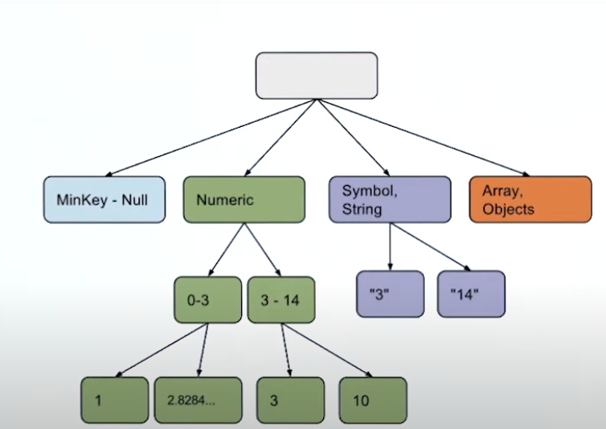

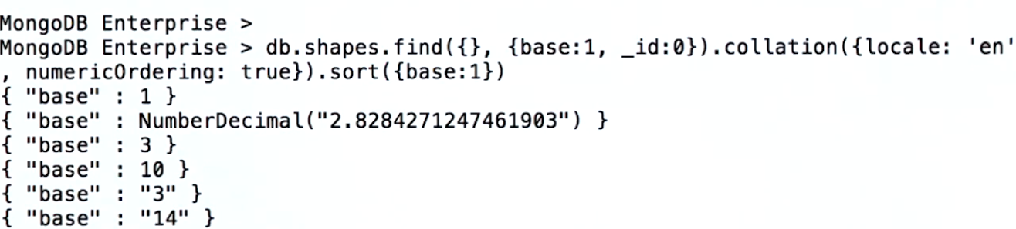

Collation with **numericOrdering** working correct.

**Aggregation Performance** - $match and $sort should be on top of Aggregation query to utilize Indexes.

To get to know Aggregation performance pass {“explain”: true} at the end of aggregation query.

**Results are subject to 16MB documents limits. [in result return]**

Each Stage of Aggregation have limit of 100MB of RAM data to process.



**allowDiskUse** – option **will not work with $graphLookup.**

Question: After adding a new consumer service, you begin to receive reports of poor query performance. You suspect disk latency may be a cause. Which tool can you use to confirm or rule out your suspicion?

Options: mongostat, mongoreplay, mongotop, mongofiles Answer is mongotop

Info > Hashed index cannot be unique.

Question: following index on the toys collection: {

"manufacturer”: 1,

"name”: 1,

"date”: -1

}

All below query will use Index:

* db.toys.find( { manufacturer : "Matteo", name : "Barbara", date : "2018-07-02" } )
* db.toys.find( { name : "Big Rig Truck", date : "2018-02-01", manufacturer : "Tanko" } )
* db.toys.find( { date : "2018-03-01", manufacturer : "Loggo", name : "Brick Set" } )

All fields used in the selection filter of the query must be in the index, so the system can find the documents that satisfy the selection filter without having to retrieve the document from the collection.

All fields returned in the results must be in the index, so again there is no need to retrieve the full document. A common mistake is not to provide a projection that filters out the field _id, which is returned by default. If the _id field is not a field in the index definition, it is not available, and the query system will need to fetch the full document to retrieve the value.

On the other hand, it is OK to ask for more fields than the ones provided in the selection filter, as long as those are in the index values, the system has all the information needed to avoid fetching the full document from the collection.

Q. You have created the following index on the foo collection:

> db.foo.createIndex( { a : 1, b : -1, c : -1, d: 1 } ) Which of the following queries will be able to fulfill the query without an in-memory sort (i.e., it's able to use the index to sort)? Check all that apply.

* db.foo.find( { a : { $gt : 100 } } ).sort( { c : -1 } )
* db.foo.find( { a : 100 } ).sort( { b : 1, c : 1 } ) [correct]
* db.foo.find( { a : 200, b : { $lt : 100 } } ).sort( { b : 1 } ) [correct]

Recall that compound indexes should be built in the order of **equality, range, sort** for common operational query patterns.

* $match can contain $text query operator.
* $where we cannot use with $match.
* $match uses same query operators as find.

**Cursor-like Stages**

**$sort, $skip, $limit, and $count are functionally equivalent to the similarly named cursor methods.**

**$sort can take advantage of indexes if used early within a pipeline.**

**By default, $sort will only use up to 100 megabytes of RAM. Setting allowDiskUse : true will allow for larger sorts.**

**$addFields -** $addFields is extremely similar to $project, with one key difference. As the name applies, $addFields adds fields to a document.

$addFields only allows you to modify the incoming pipeline documents with new computed fields or to modify existing fields.

$geoNear – geo json data, Within a pipeline, $geoNear must be the first stage in a pipeline. So if we already have $near operator available for find operations, why do we need an aggregation stage like $geoNear?

$geoNear can be used on charted collections, whereas $near can't.

Additionally, any query using $near cannot use other special indexes, like $text, for example.

One last thing, $geoNear requires that the collection we're performing our aggregations on to have one and only one geoindex. Specify true if the index is a 2dsphere, otherwise false.

* The collection can have one and only one 2dsphere index.
* If using 2dsphere, the distance is returned in meters.
* If using legacy coordinates, the distance is returned in radians.
* And $geoNear must be the first stage in an aggregation pipeline.

$Sample - will select a set of random documents from a collection in one of two ways. The first method is if the size that we are specifying, the N number of documents that we want our sample to be looking like, if it's less than 5% of the number of documents in our source collection, and the source collection has more than 100 documents, and $sample is the first stage, then a pseudo-random cursor will select the specific number of documents to be passed on.

If all other conditions, and let's recap them very quickly, if N is more than 5% or the source collection has less than 100 documents, or if sample is not the first stage, if any of these conditions does not apply, then what is done is a in-memory random sort and select the specific number of documents that we specify as the size.

Now this sort will be subjected to the same memory restrictions as the sort stage of our aggregation pipeline.

$qroup – stage

* **_id** is where we specify what incoming documents should be grouped on.
* We can use all accumulator expressions within group.
* Group can be used multiple times within a pipeline, and it may be necessary to sanitize incoming data.
* By convention, we group all documents together by specifying null` to ``_id.

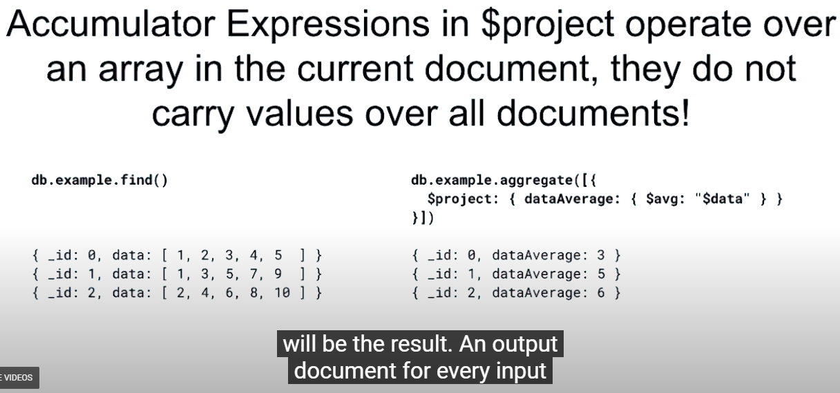

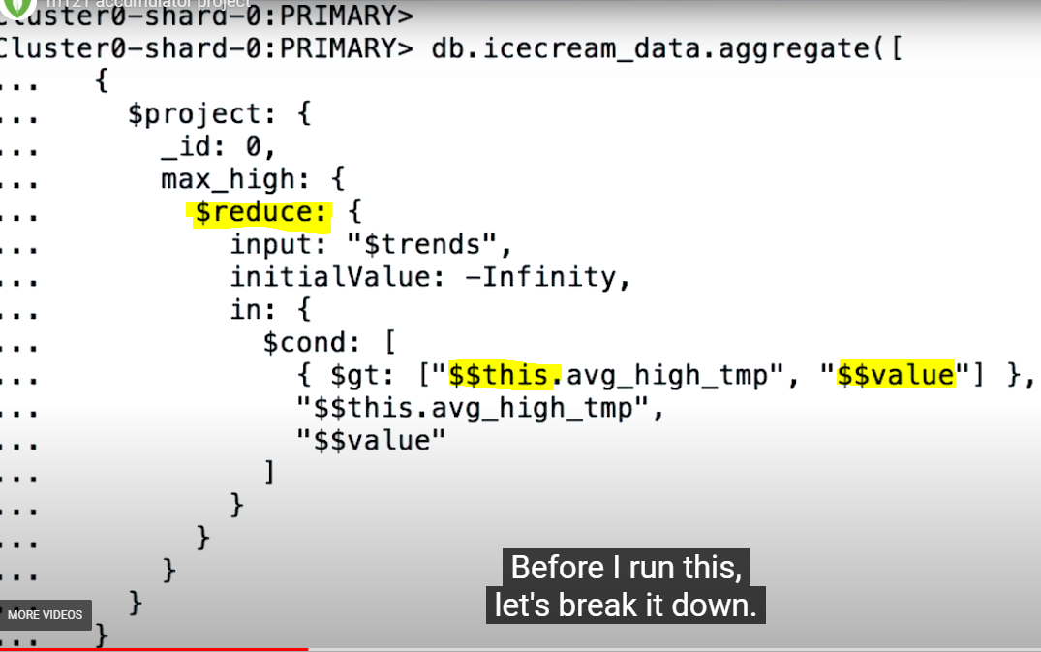

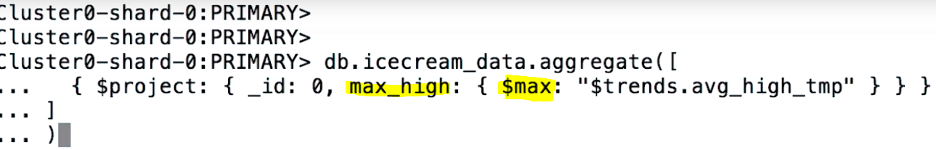

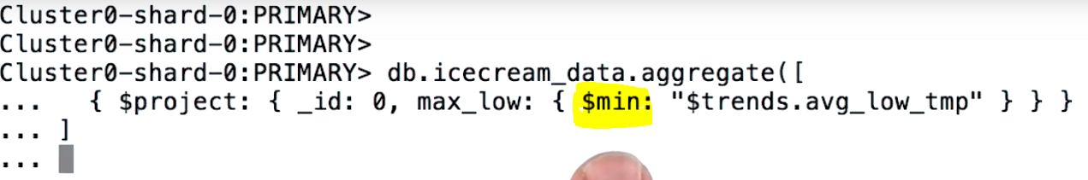

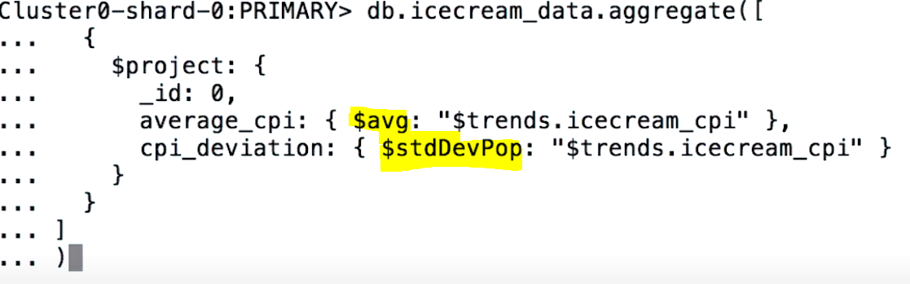

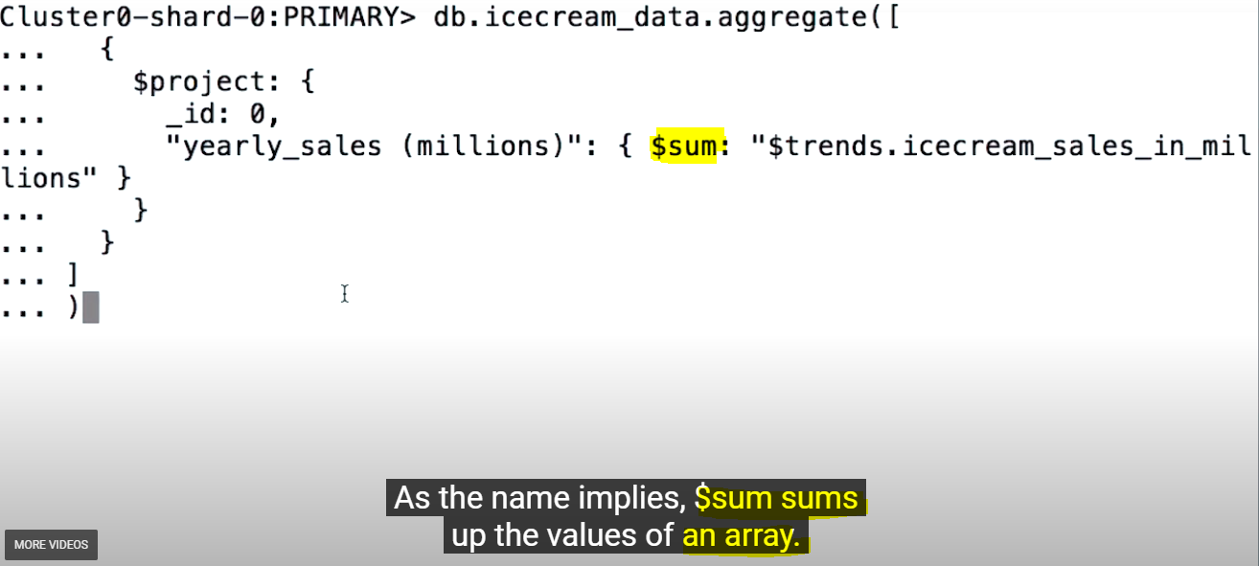





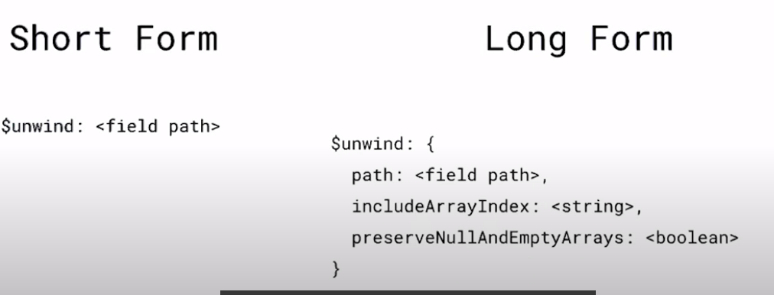

The $lookup Stage – left outer Join as per SQL relational database

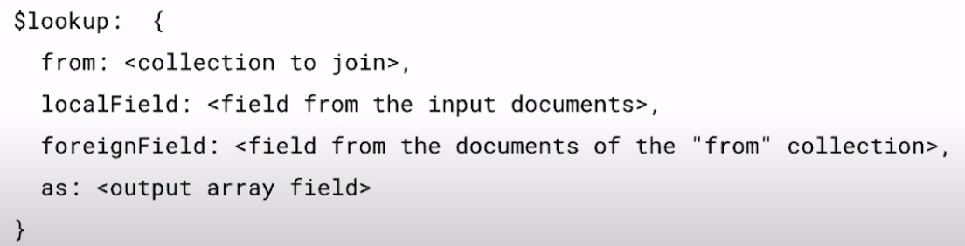

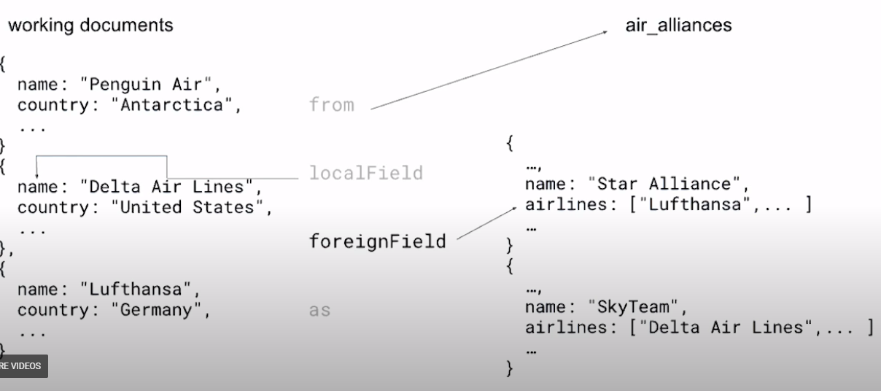

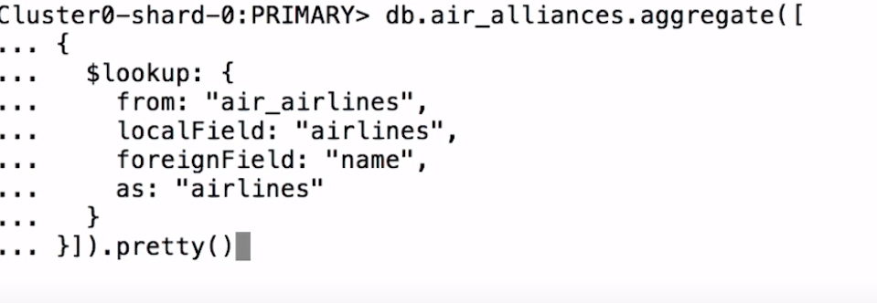

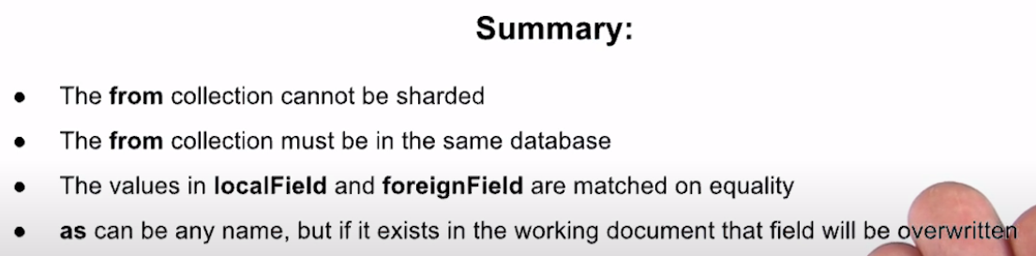

**$graphLookup Introduction –** Organizational Reporting

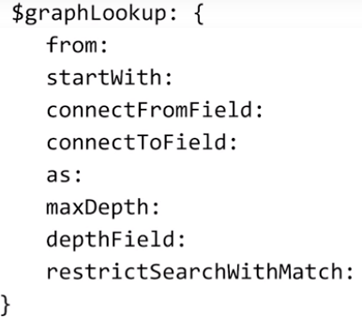

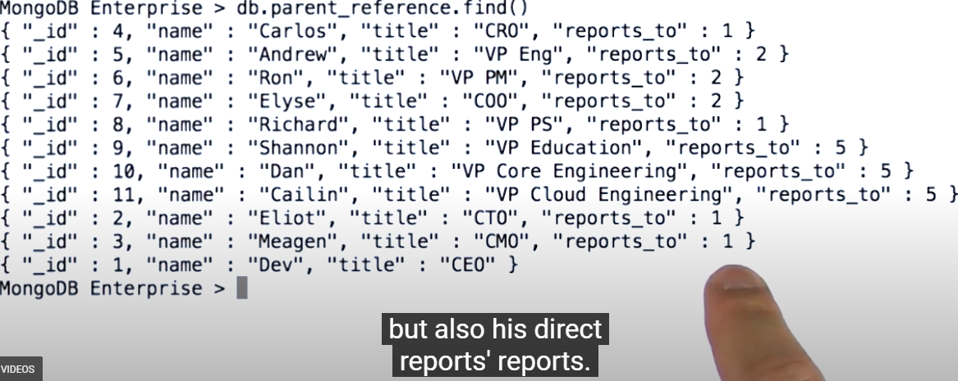

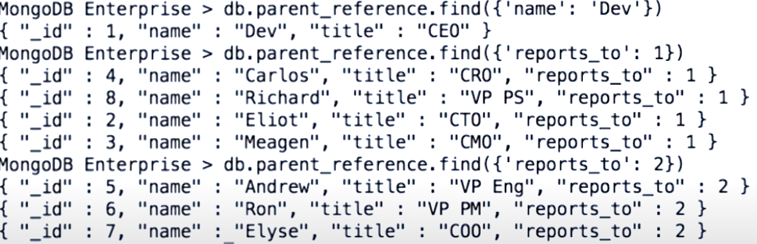

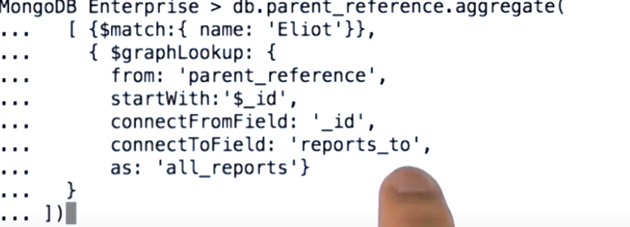

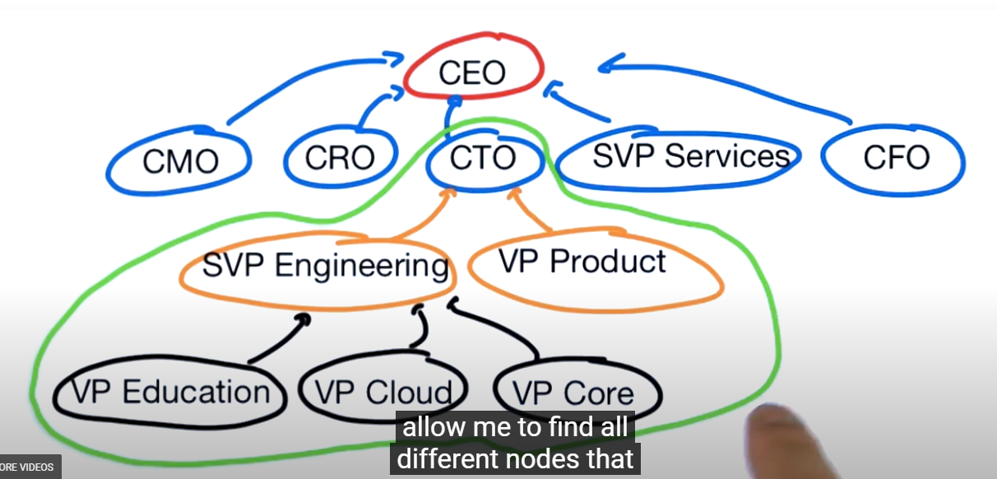

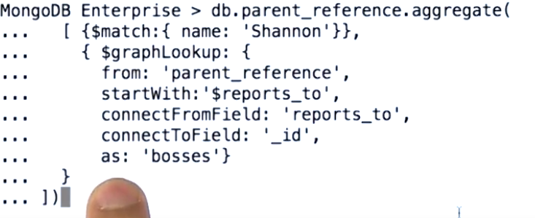



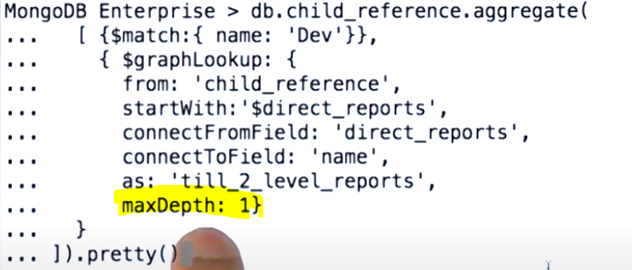

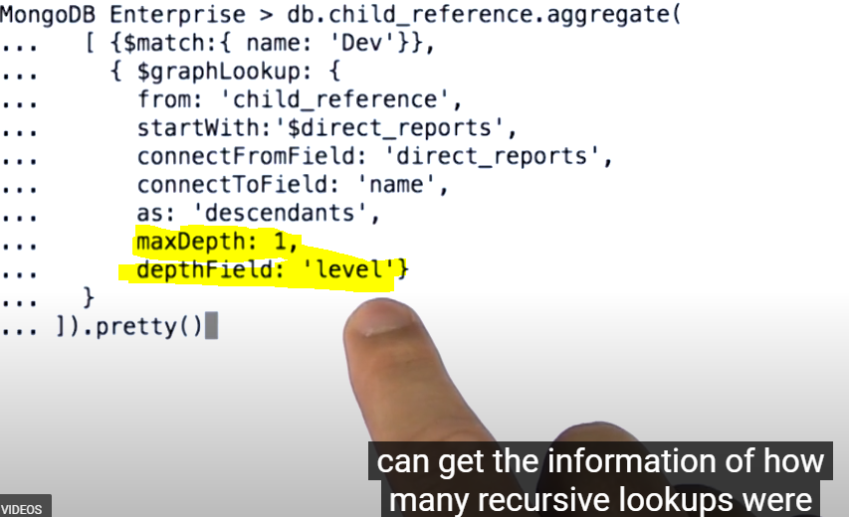

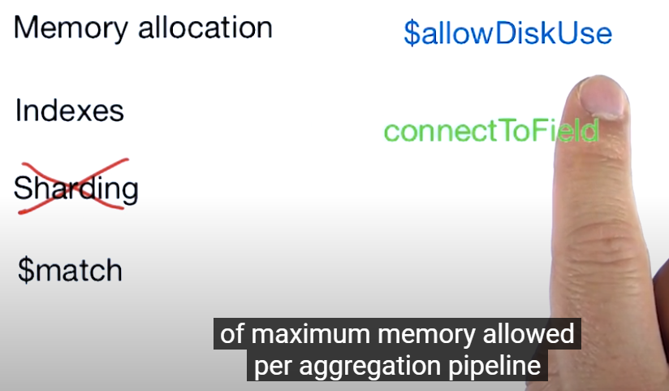

**Facets: Introduction –**

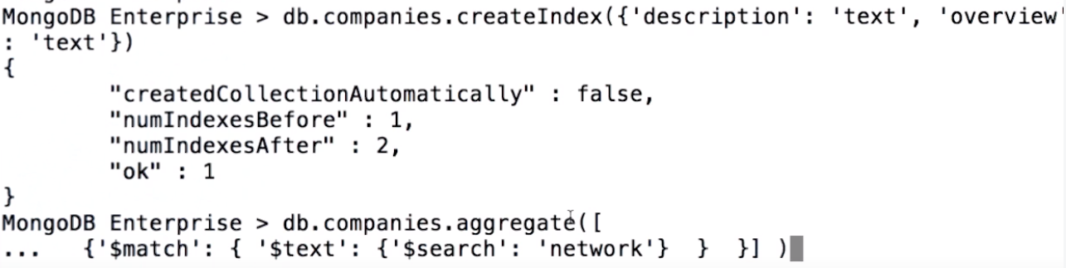

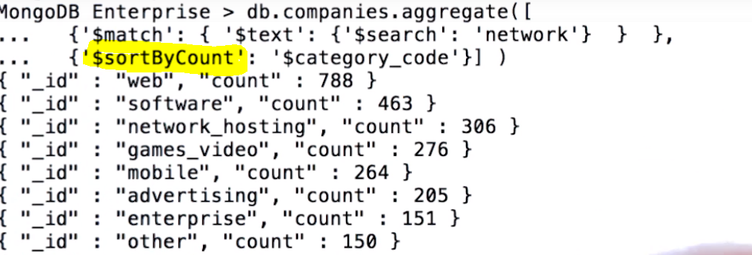

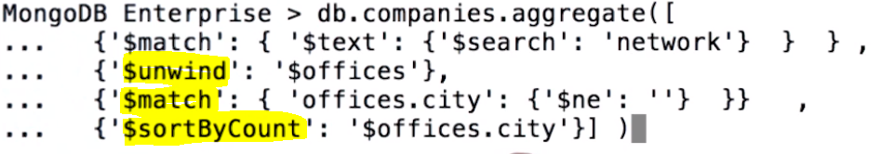

**Single query facets are supported by the new aggregation pipeline stage $sortByCount.**

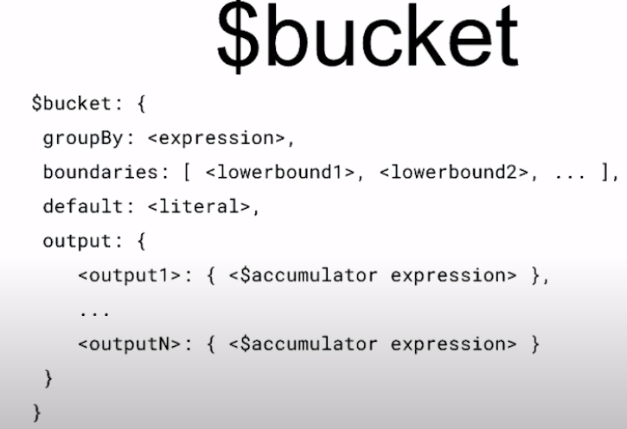

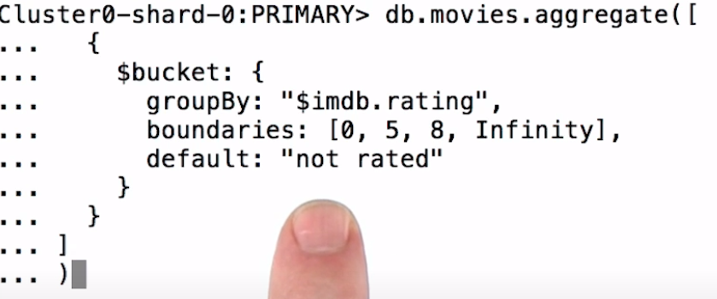

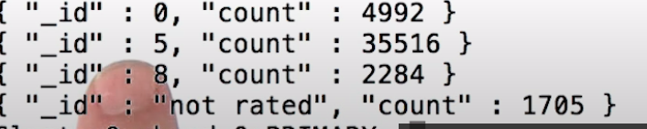

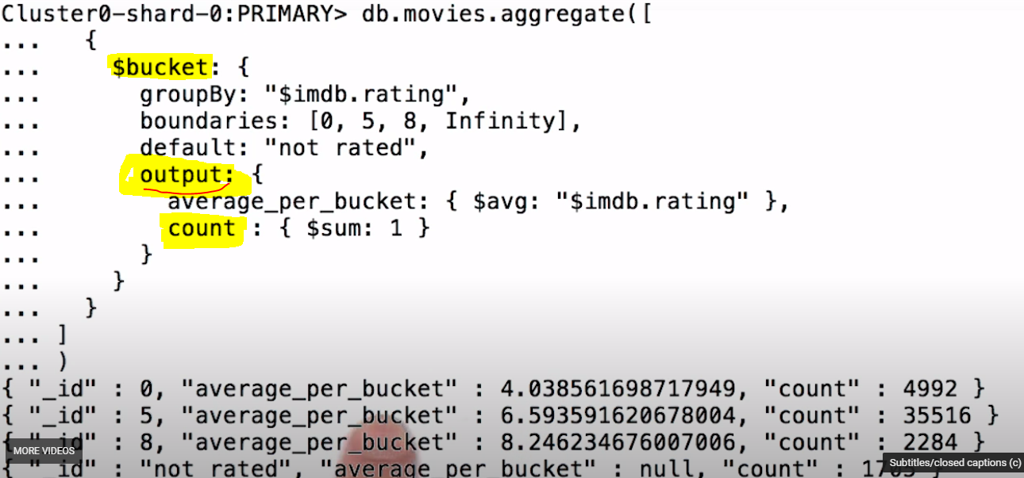

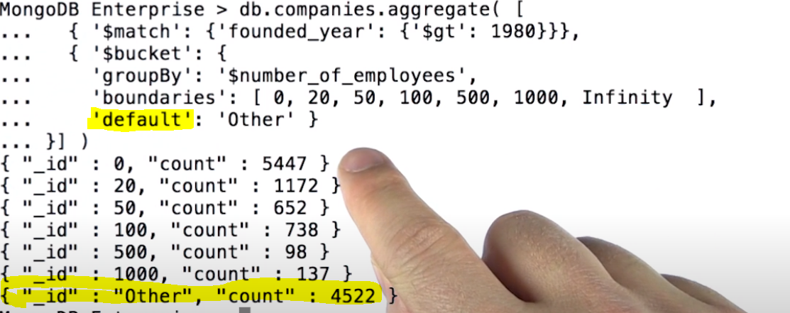

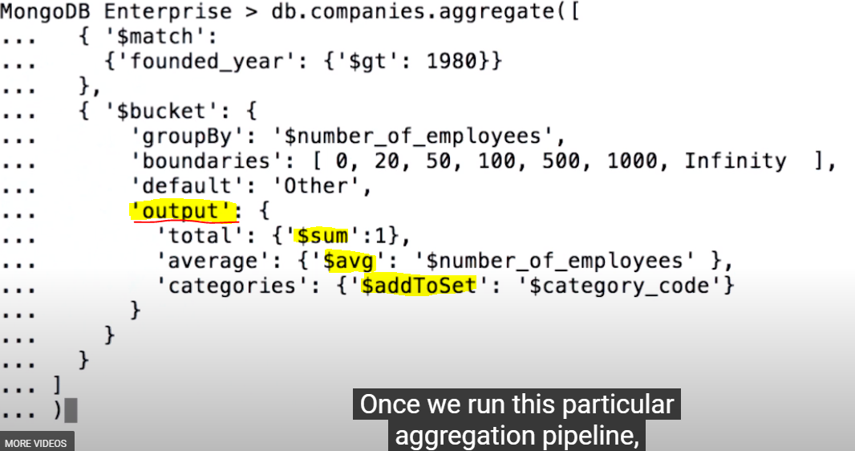

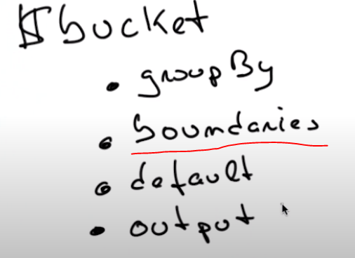

**AutoBucket** – Instead of defining boundaries, we just let MongoDB figure those out by specifying how many buckets we want.

$$**bucketAuto** will attempt to evenly distribute the documents into the specified number of buckets, calculating the boundaries for us.

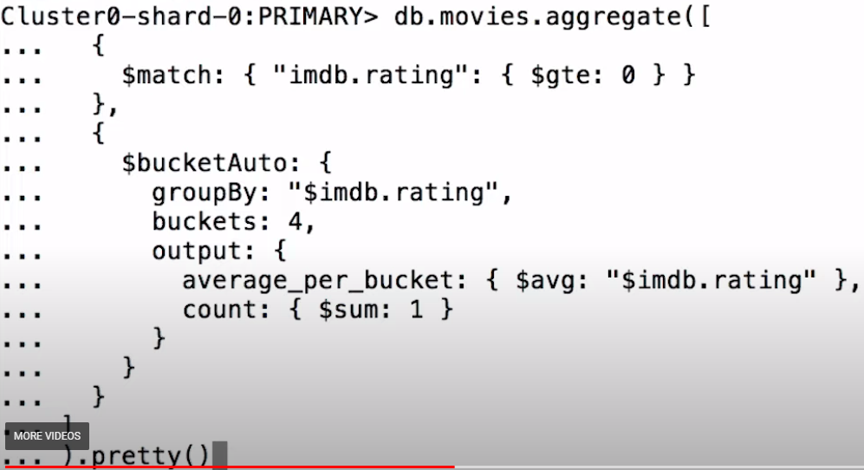



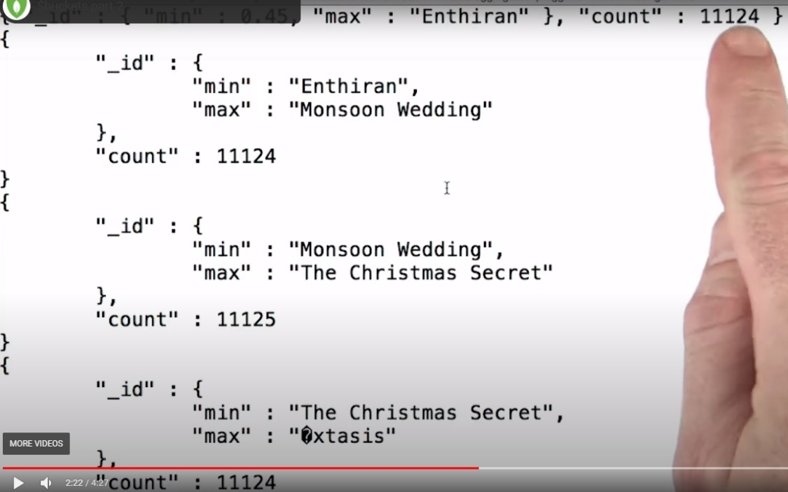

Much More Even distribution of Documents - (11124)

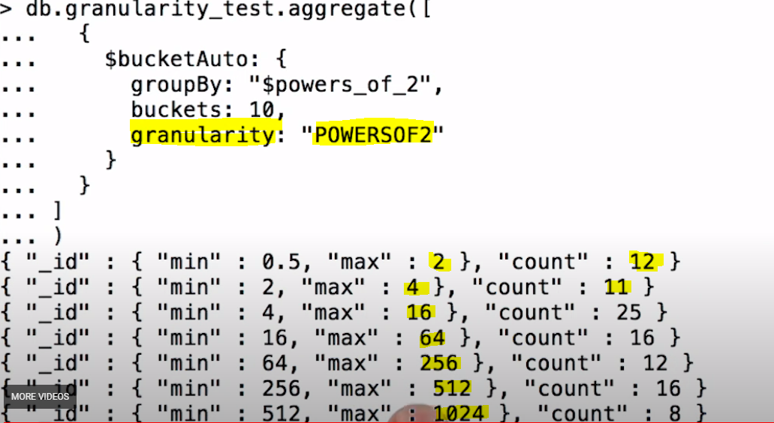

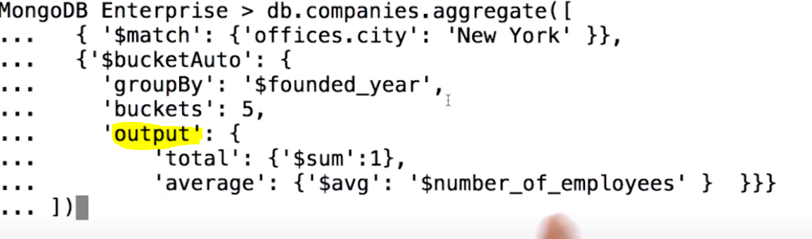

**Multiple Facets in one grouping of $facet**

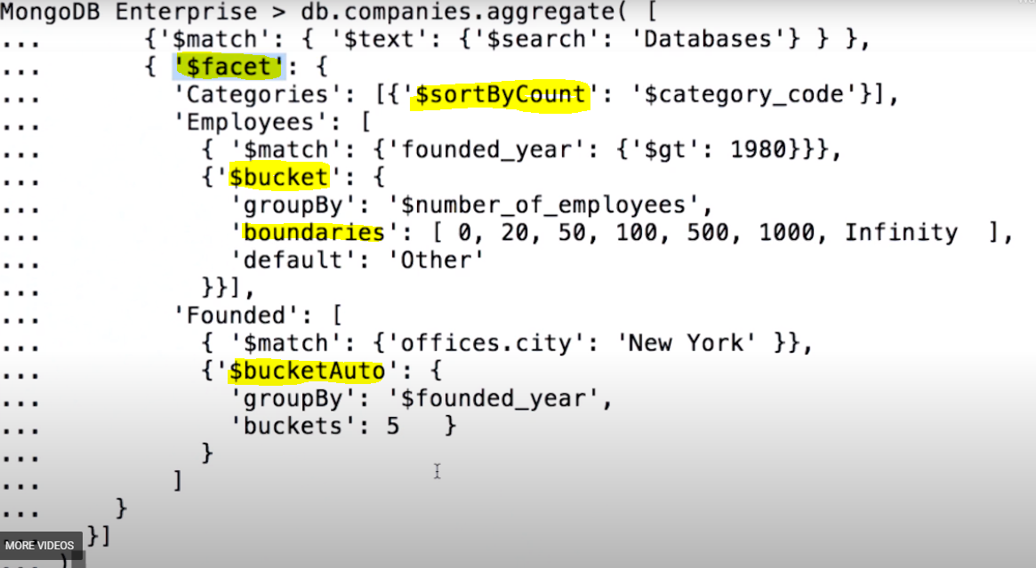

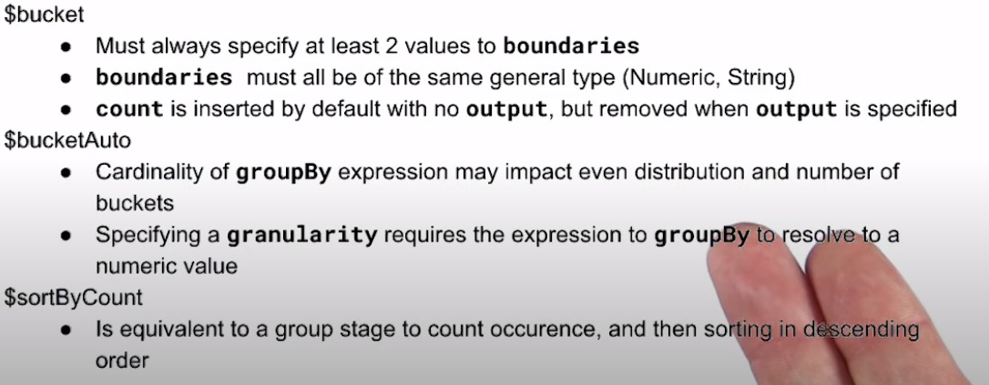

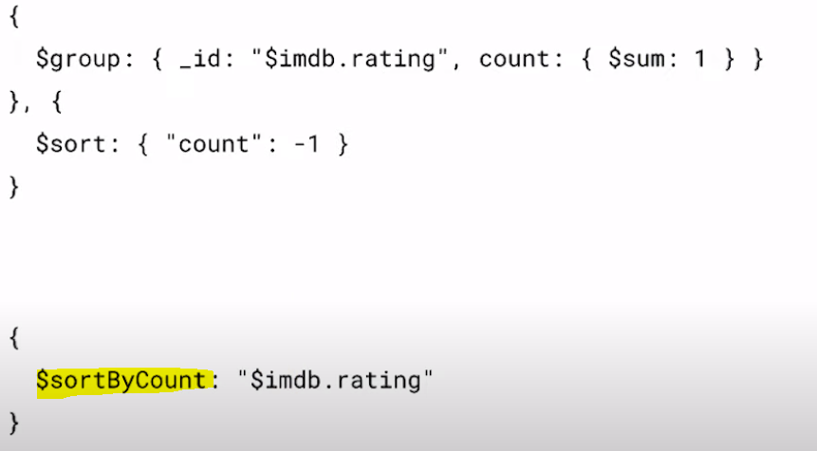

**$sortByCount** giving same result as above one aggregation pipe line giving

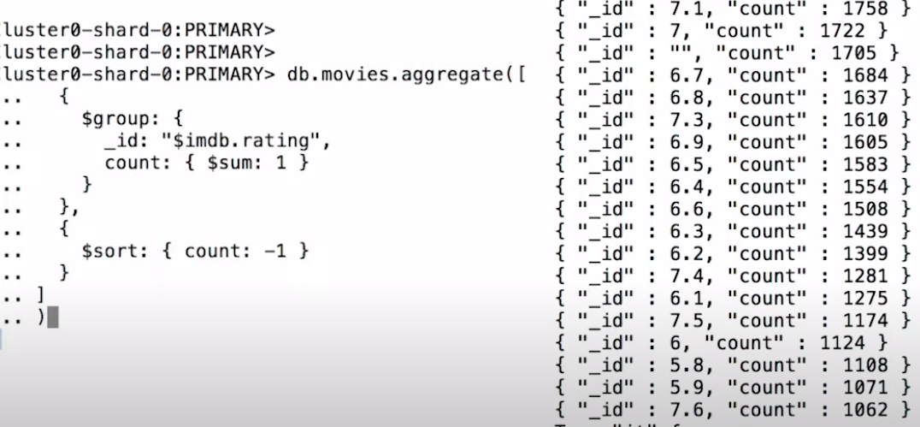

**The $redact Stage –**

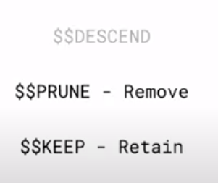

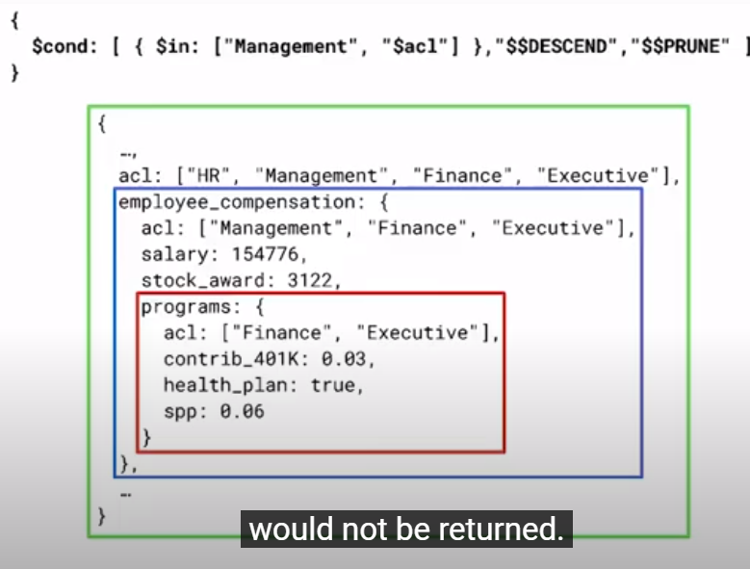

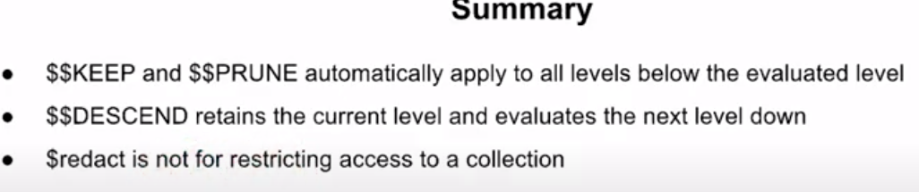

**$OUT –**

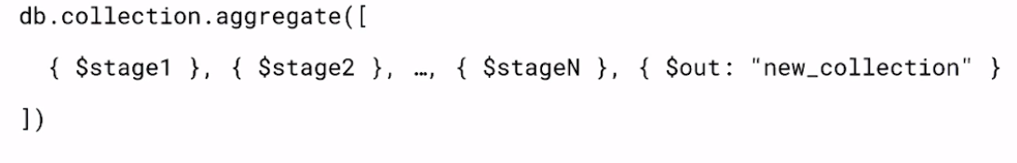

**The out stage must be the last stage of pipe.**

**NO use with $facet!**

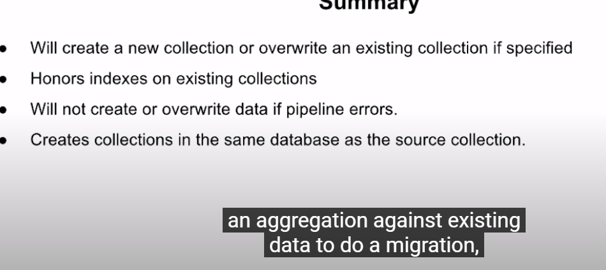

**View Creation -**

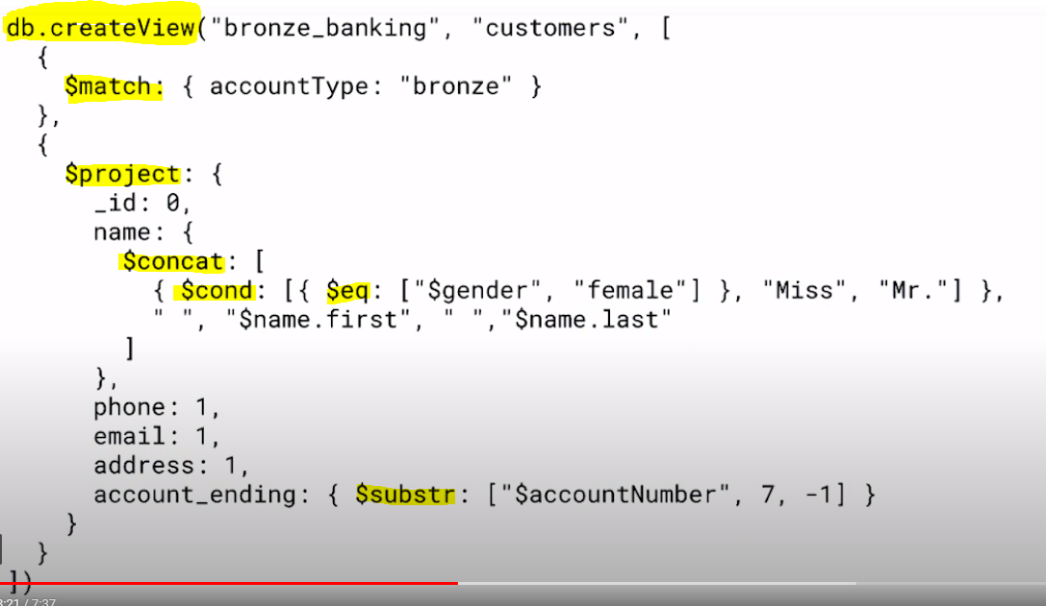

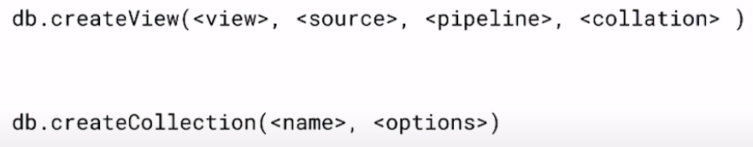

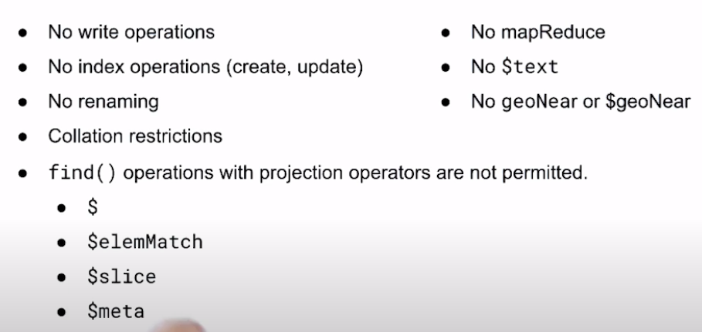

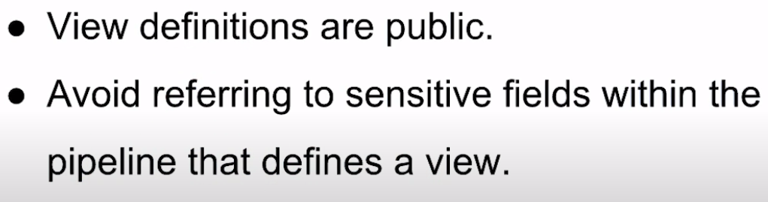

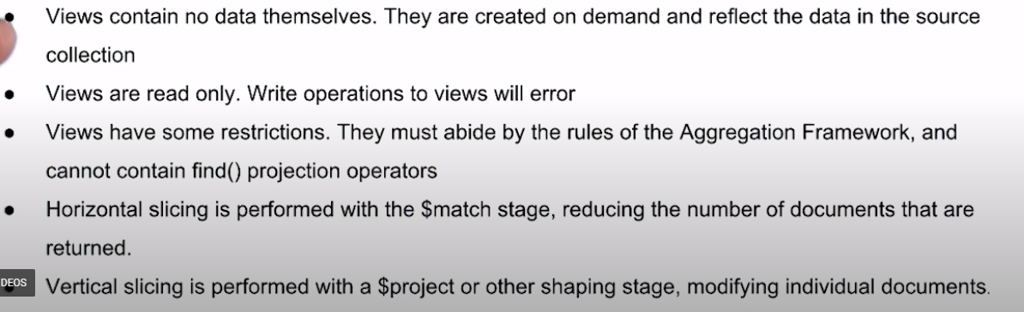

**Aggregation Performance -**

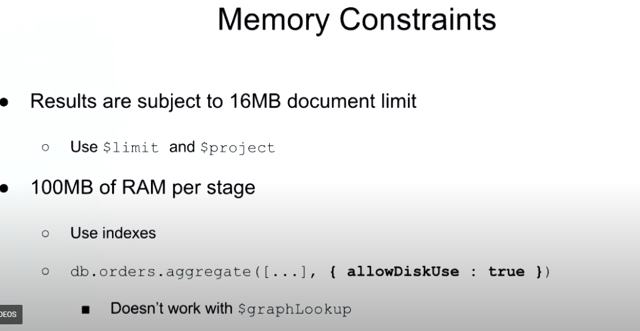

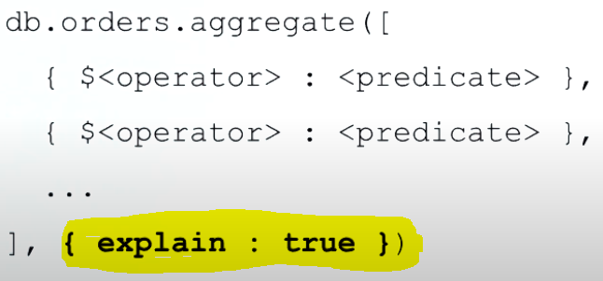

**Aggregation Pipeline on a Sharded Cluster -**

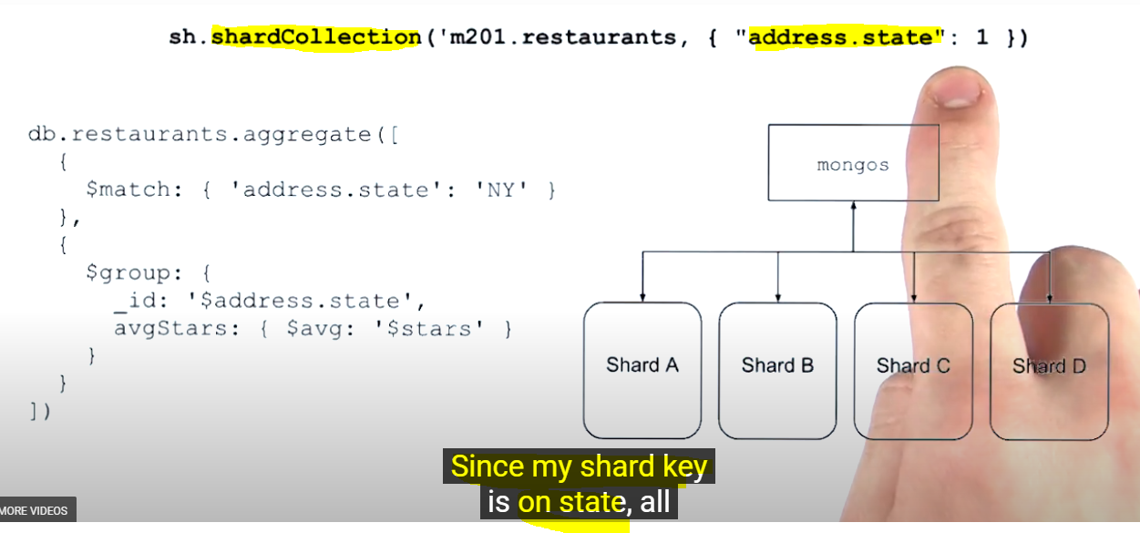

**Using Below stages merging will happen at primary shard – so primary shard may impact of performance and it is also not solving the purpose of horizontal scaling -**

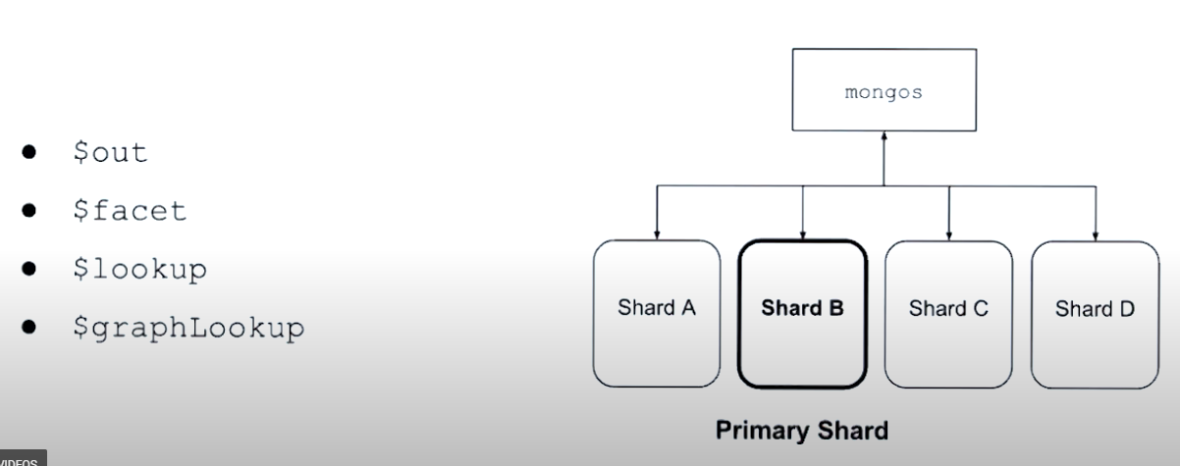

**Aggregation Optimizations –**

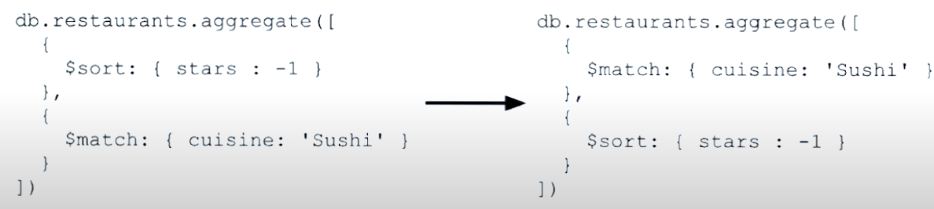

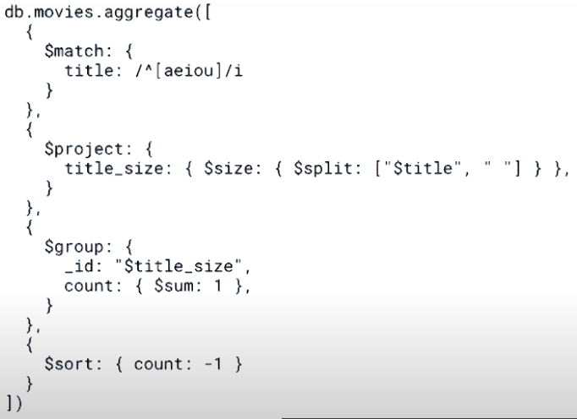

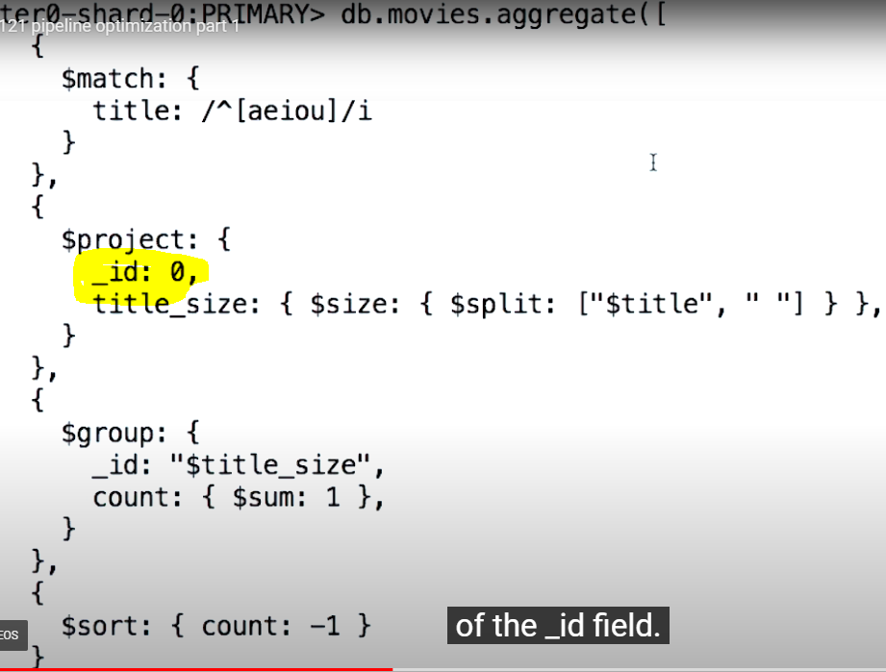

**NO fetch stage it’s mean MongoDB using indexes to get all info instead of document.**

**NO fetch stage means also this is covered query.**

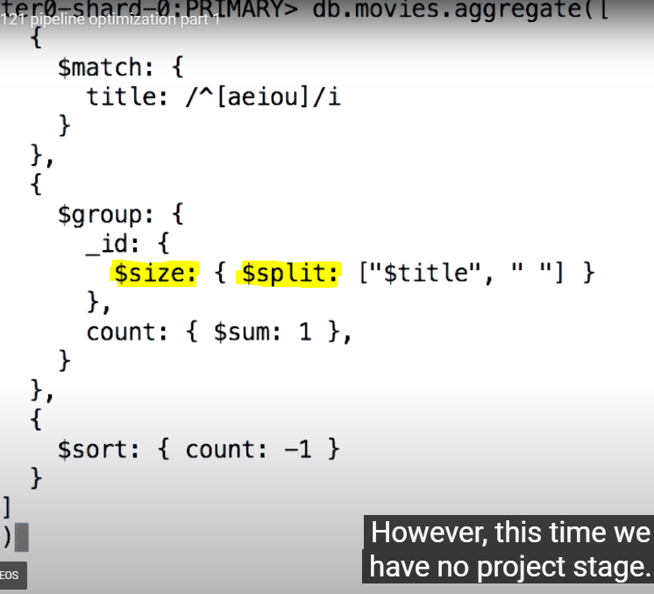

**We got the same result –**

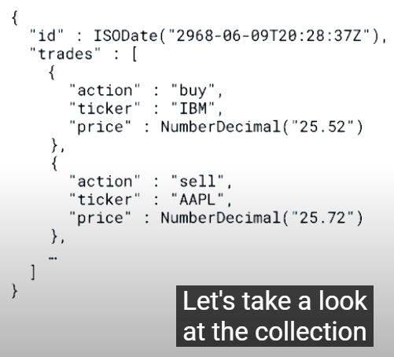

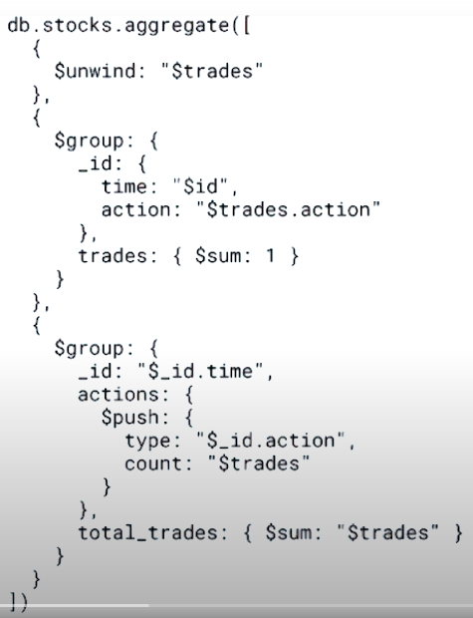

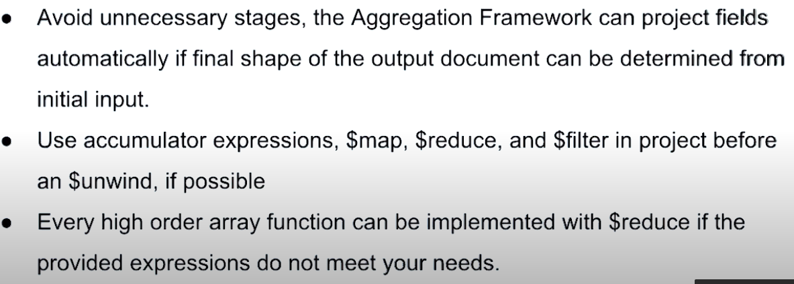

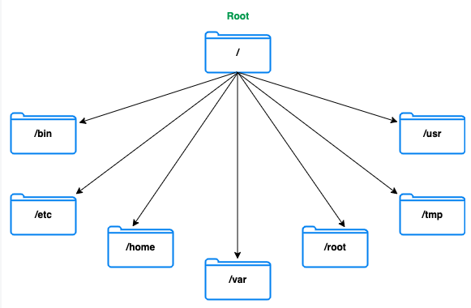

**Linux – Directory structure**

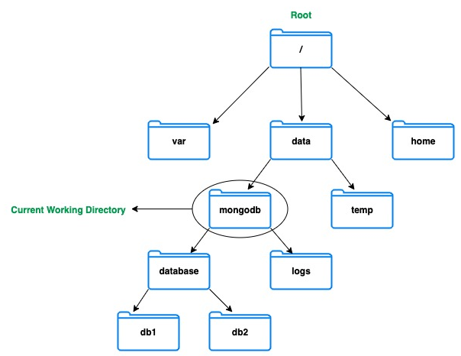

**ps -ef | grep mongo**

**ps -ef | grep mongod**

**ps -ef | grep mongos**

**----------------------------**

**kill 13029**

**killall mongod**

**-----------------------------**

**use admin**

**db.shutdownServer()**

**exit**

**mongod --dbpath <directory path>**  /data/db

**mongod --port <port number>** /27017

**mongod** **--auth**

**mongod** **--bind_ip** localhost,123.123.123.123 localhost or 127.0.0.1

To bind to multiple addresses and/or hosts, you can specify them in a comma-separated list:

mongod **--dbpath** /data/db **--logpath** /data/log/mongod.log **--fork** **--replSet** "M103" **--keyFile** /data/keyfile **--bind_ip** "127.0.0.1,192.168.103.100" **--tlsMode** requireTLS **--tlsCAFile** "/etc/tls/TLSCA.pem" **--tlsCertificateKeyFile** "/etc/tls/tls.pem"

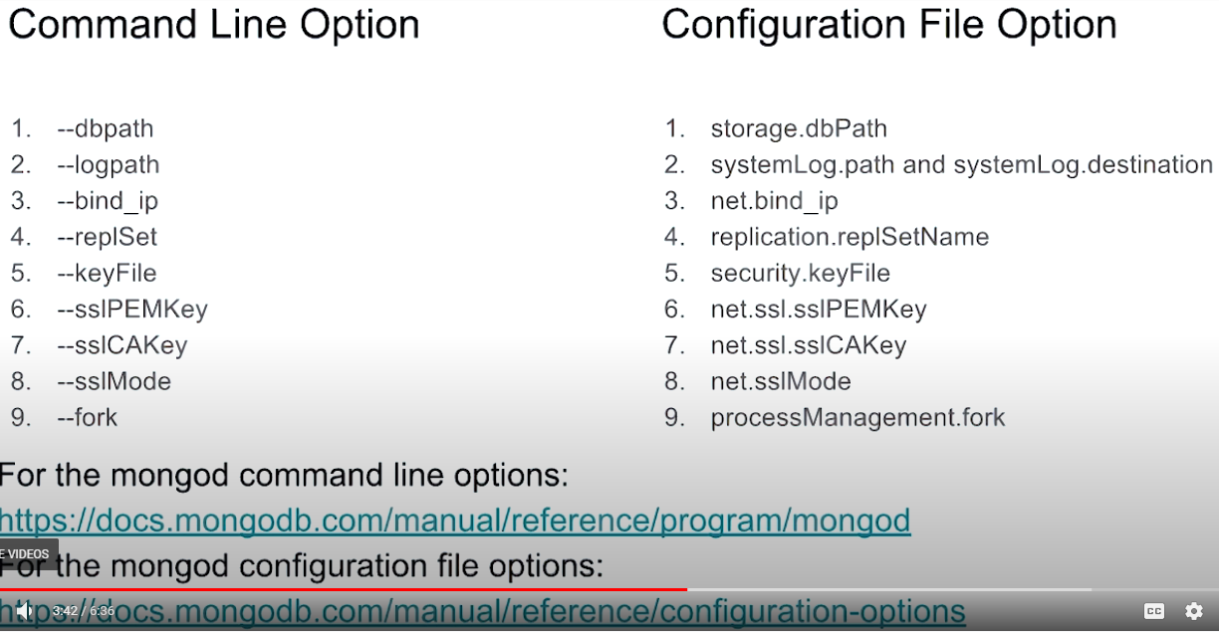

How to use MongoDB Configuration file -

**mongod --config “/etc/mongod.conf”**

**mongod --f “/etc/mongod.conf”**

**storage:**

dbPath: "/data/db"

**systemLog:**

path: "/data/log/mongod.log"

destination: "file"

**replication:**

replSetName: M103

**net:**

bindIp : "127.0.0.1,192.168.103.100"

**tls:**

mode: "requireTLS"

certificateKeyFile: "/etc/tls/tls.pem"

CAFile: "/etc/tls/TLSCA.pem"

**security:**

keyFile: "/data/keyfile"

**processManagement:**

fork: true

Create User -

mongo admin --host localhost:27000 --eval '

db.createUser({

user: "m103-admin",

pwd: "m103-pass",

roles: [

{role: "root", db: "admin"}

]

})'

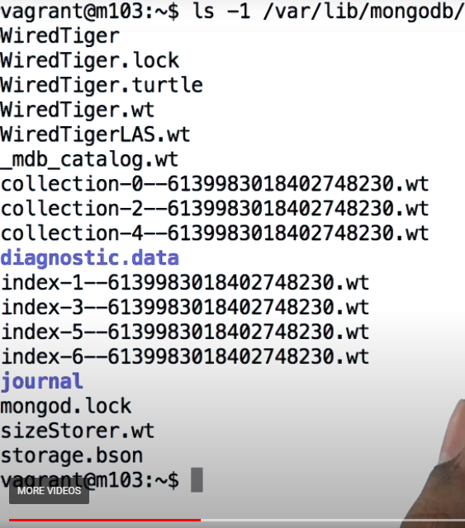

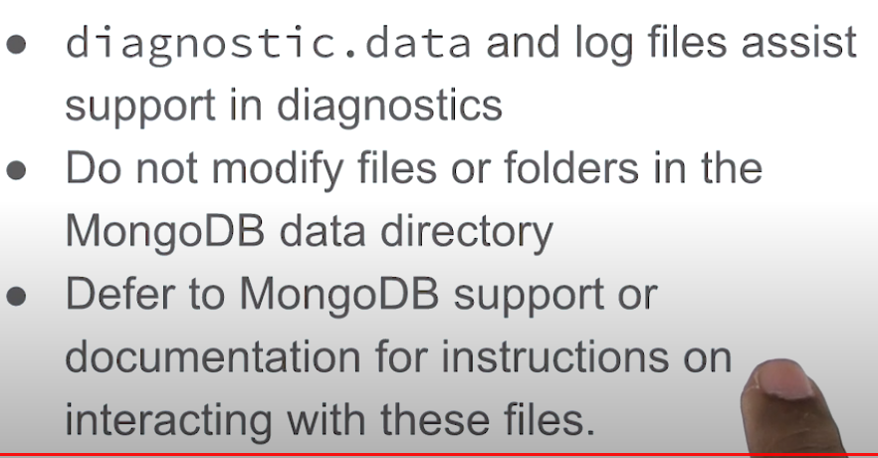

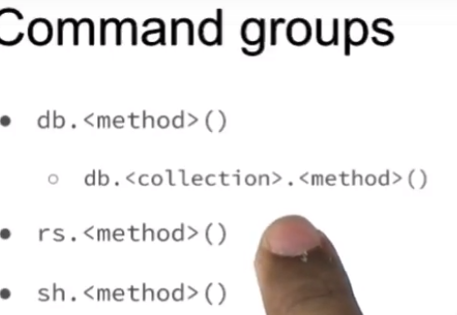

**User management commands:**

db.createUser()

db.dropUser()

**Collection management commands:**

db.<collection>.renameCollection()

db.<collection>.createIndex()

db.<collection>.drop()

**Database management commands:**

db.dropDatabase()

db.createCollection()

**Database status command:**

db.serverStatus()

**Creating index with Database Command:**

db.runCommand(

{ "createIndexes": <collection> },

{ "indexes": [

{

"key": { "product": 1 }

},

{ "name": "name_index" }

]

}

)

**Creating index with Shell Helper:**

db.<collection>.createIndex(

{ "product": 1 },

{ "name": "name_index" }

)

**Introspect a Shell Helper:**

db.<collection>.createIndex

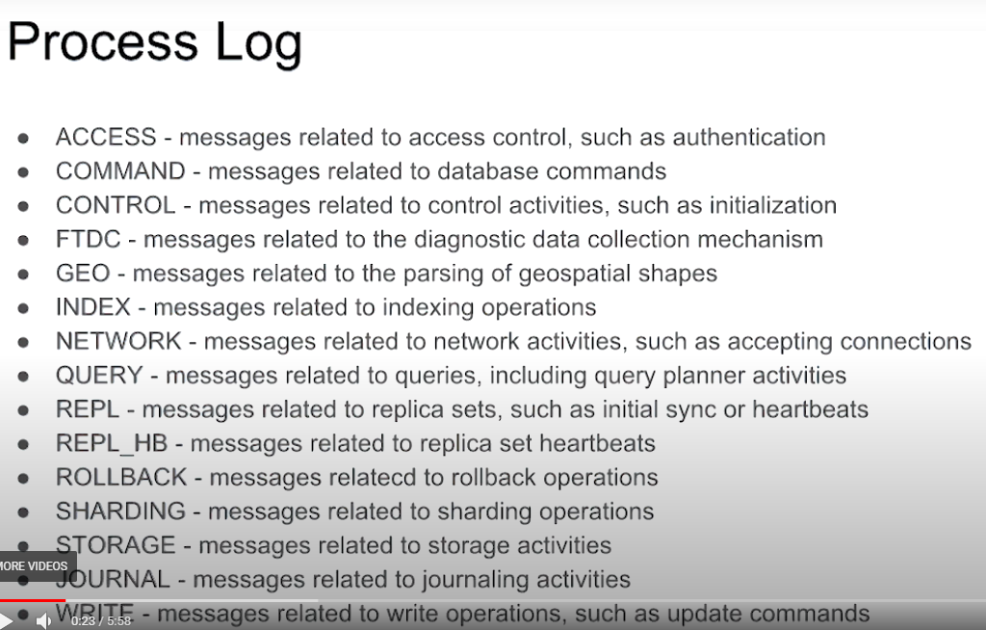

**db.getLogComponents()**

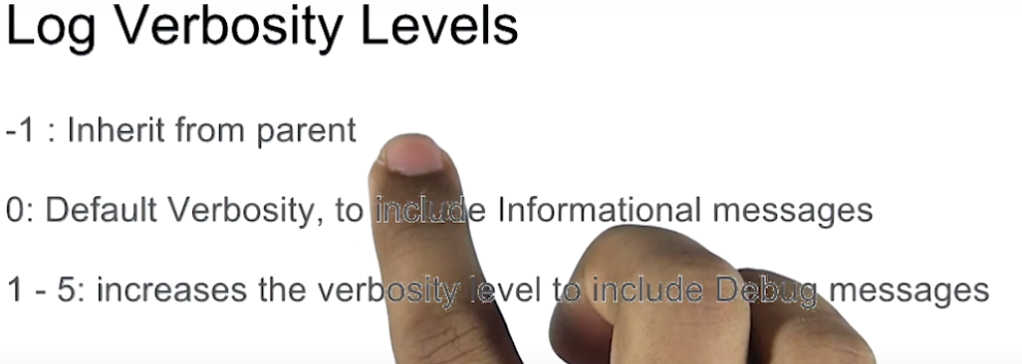





After setting log Level again rerun – **db.getLogComponents()**

Other Way of looking LOG-



Look for instructions in the log file with grep:

**grep -i 'update' /data/db/mongod.log**

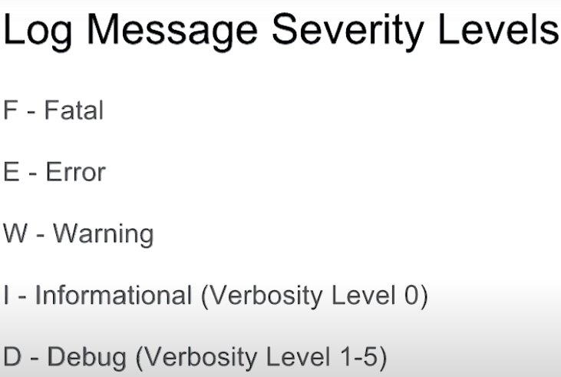

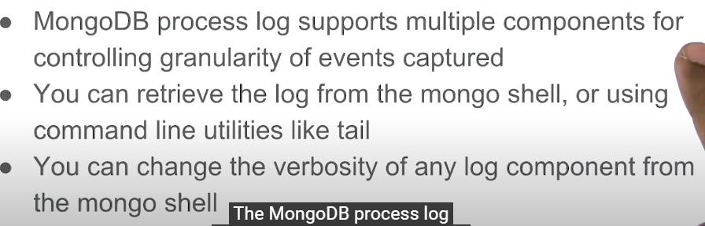

Profiling The DataBase –

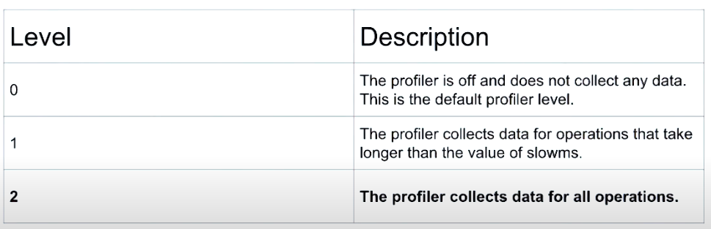

db.getProfilingLevel()

db.setProfilingLevel(1) - queries took 100MS only be profile

show collection will show new collection created – show.collections

**system.profile**

db.setProfilingLevel(1, {slowms : 0}) //every query will go in profiling regardless of timing took.

Now insert some document in selected db and after that check profiling collection –

>**db.system.profile.find().pretty()**

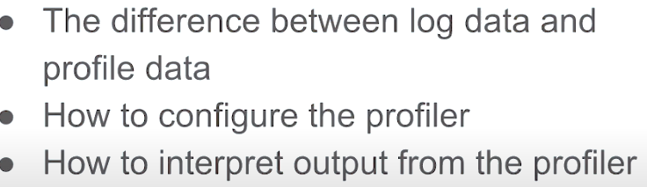

>mongo newDB --host 192.168.103.100:27000 -u m103-admin -p m103-pass --authenticationDatabase admin --eval **'db.system.profile.find().pretty()**'

However, Network timeouts and WiredTiger storage data are not captured by the profiler - this data is stored in the logs instead.

**Available Authentication Mechanisms -**

* In Community and Enterprise edition have
  1. SCRAM [“Salted Challenge Response” by default minimal it should be there]
  2. X509
* In Enterprise Only

1. LDAP
2. KARBEROS

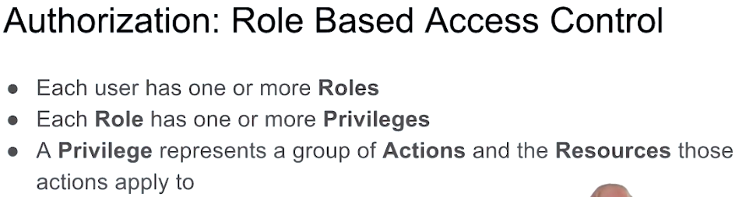

Mongo DB also support intra-cluster authentication. MongoDB provides both cluster and client authentication

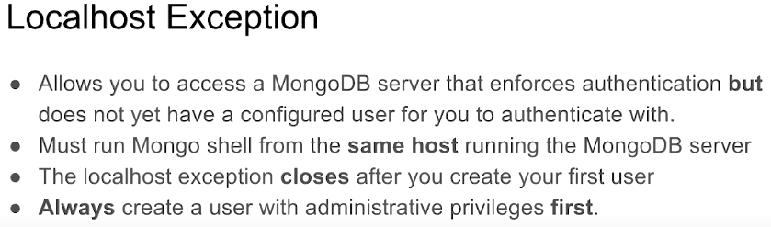

>mongo –host 127.0.0.1:20017

>use admin

db.createUser({

user: "root",

pwd: "root123",

roles : [ "root" ]

});

>db.status() //will show exception because you are not a authentic user

First create user with “root” privileges and do login first using the same user so that further user with diffident role can be create.

>mongo –host 127.0.0.1:27017 \

> --username root \

> --password root \

> --authenticationDatabase admin

Now run > db.status()

>use admin

>db.shutdownServer()

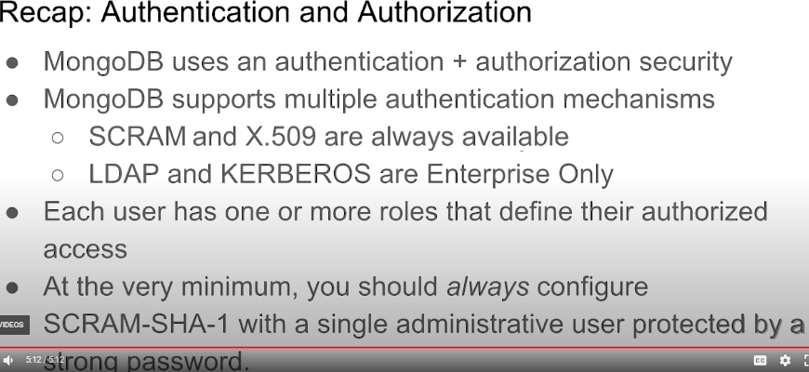

**Built-In-Roles –**

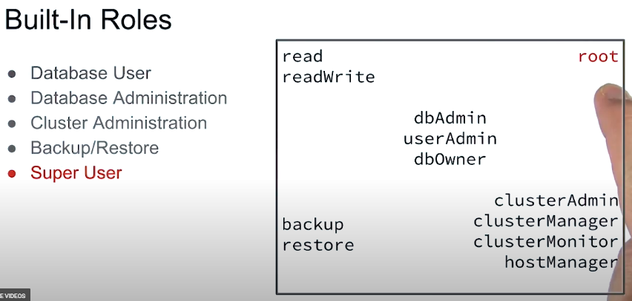

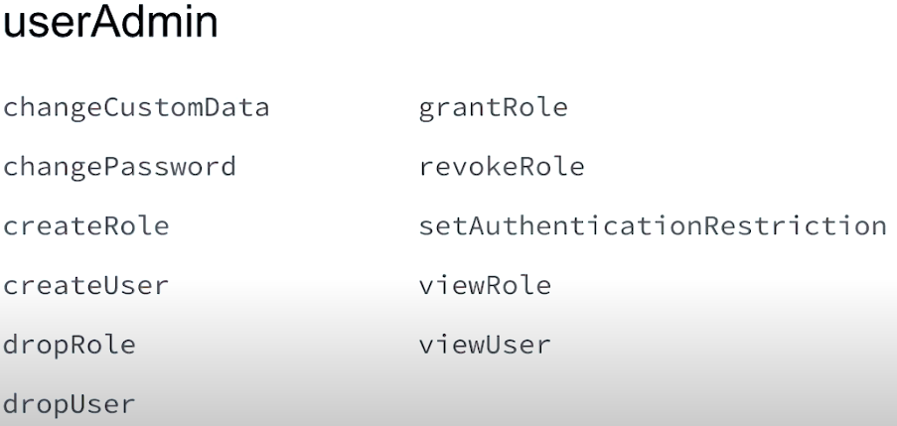

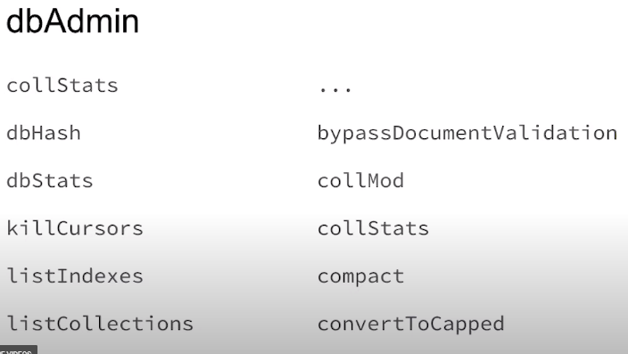

**DDL can do [No document creation, but can remove collection]**

**Create security officer:**

db.createUser(

{ user: "security_officer",

pwd: "h3ll0th3r3",

roles: [ { db: "admin", role: "userAdmin" } ]

}

)

**Create database administrator:**

db.createUser(

{ user: "dba",

pwd: "c1lynd3rs",

roles: [ { db: "admin", role: "dbAdmin" } ]

}

)

**Grant role to user:**

db.grantRolesToUser( "dba", [ { db: "playground", role: "dbOwner" } ] )

**Show role privileges:**

db.runCommand( { rolesInfo: { role: "dbOwner", db: "playground" }, showPrivileges: true} )

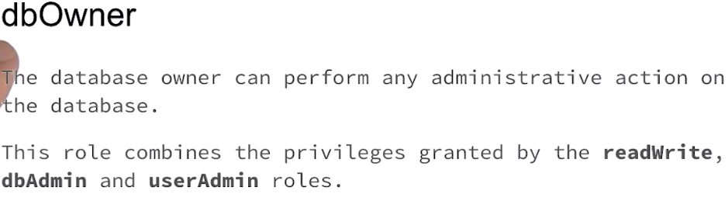

**>mongo --port 27000 -u "m103-admin" -p "m103-pass" --authenticationDatabase "admin"**

**>use admin**

db.createUser({user: "m103-application-user", pwd: "m103-application-pass",roles: [{role: "readWrite", db: "applicationData"}]})

**List mongodb binaries**:

>find /usr/bin/ -name "mongo*"

**Create new dbpath and launch mongod**:

>mkdir -p ~/first_mongod

>mongod --port 30000 --dbpath ~/first_mongod --logpath ~/first_mongod/mongodb.log --fork

**Use mongostat to get stats on a running mongod process:**

>mongostat --help

>mongostat --port 30000

**Use mongodump to get a BSON dump of a MongoDB collection:**

>mongodump --help

>mongodump --port 30000 --db applicationData --collection products

ls dump/applicationData/

>cat dump/applicationData/products.metadata.json

**Use mongorestore to restore a MongoDB collection from a BSON dump:**

>mongorestore --drop --port 30000 dump/

**Use mongoexport to export a MongoDB collection to JSON or CSV (or stdout!):**

>mongoexport --help

>mongoexport --port 30000 --db applicationData --collection products

>mongoexport --port 30000 --db applicationData --collection products **-o products.json**

**Tail the exported JSON file:**

>tail products.json

**Use mongoimport to create a MongoDB collection from a JSON or CSV file:**

>mongoimport --port 30000 products.json



mongoimport --drop --port 27000 -u "m103-application-user" \

-p "m103-application-pass" --authenticationDatabase "admin" \

--db applicationData --collection products /dataset/products.json

We authenticate to the database the same way with mongoimport as we did with mongo.

The flags --db and --collection are used to designate a target database and collection for our data.

The flag --drop is used to drop the existing collection, so we don't create duplicates by running this command twice.

**Two kinds of replications are in Replica Set –**

1. Statement Base Replication [**MngoDB Supports**] stores in Oplog – idempotency , No Machine level dependency
2. Binary Replication [Binary Log] – Faster, Less Data

**Asynchronous Replication Protocol** version – Pv1, Pv0 [From Primary to Secondary] Pv1 is based upon RAFT protocol.

Arbiter Node – Holds **no Data**, **cannot be Primary**, **can vote in Election**

Max 7 members can be voting member in maximum 50 replicaset members

**Create ReplicaSet-**

The configuration file for the first node (node1.conf):

storage:

dbPath: /var/mongodb/db/node1

net:

bindIp: 192.168.103.100,localhost

port: 27011

security:

authorization: enabled

keyFile: /var/mongodb/pki/m103-keyfile

systemLog:

destination: file

path: /var/mongodb/db/node1/mongod.log

logAppend: true

processManagement:

fork: true

replication:

replSetName: m103-example

**Creating the keyfile and setting permissions on it:**

sudo mkdir -p /var/mongodb/pki/

sudo chown vagrant:vagrant /var/mongodb/pki/

openssl rand -base64 741 > /var/mongodb/pki/m103-keyfile

chmod 400 /var/mongodb/pki/m103-keyfile

**Creating the dbpath for node1:**

mkdir -p /var/mongodb/db/node1

**Starting a mongod with node1.conf**:

mongod -f node1.conf

**Copying node1.conf to node2.conf and node3.conf:**

cp node1.conf node2.conf

cp node2.conf node3.conf

**Editing node2.conf using vi:**

vi node2.conf

**Saving the file and exiting vi:**

:wq

node2.conf, after changing the dbpath, port, and logpath:

storage:

dbPath: /var/mongodb/db/node2

net:

bindIp: 192.168.103.100,localhost

port: **27012**

security:

**keyFile: /var/mongodb/pki/m103-keyfile**

systemLog:

destination: file

**path: /var/mongodb/db/node2/mongod.log**

logAppend: true

processManagement:

fork: true

replication:

**replSetName: m103-example**

node3.conf, after changing the dbpath, port, and logpath:

storage:

dbPath: /var/mongodb/db/node3

net:

bindIp: 192.168.103.100,localhost

**port: 27013**

security:

**keyFile: /var/mongodb/pki/m103-keyfile**

systemLog:

destination: file

**path: /var/mongodb/db/node3/mongod.log**

logAppend: true

processManagement:

fork: true

replication:

**replSetName: m103-example**

**Creating the data directories for node2 and node3**:

mkdir /var/mongodb/db/{node2,node3}

Starting mongod processes with **node2.conf** and **node3.conf**:

**mongod -f node2.conf**

**mongod -f node3.conf**

**Connecting to node1**:

mongo --port 27011

**Initiating the replica set**:

rs.initiate()

**Creating a user:**

use admin

db.createUser({

user: "m103-admin",

pwd: "m103-pass",

roles: [

{role: "root", db: "admin"}

]

})

**Exiting out of the Mongo shell and connecting to the entire replica set**:

exit

mongo --host "**m103-example**/192.168.103.100:27011" -u "m103-admin"

-p "m103-pass" --authenticationDatabase "admin"

**Getting replica set status:**

rs.status()

**Adding other members to replica set:**

rs.add("m103:27012")

rs.add("m103:27013")

**Getting an overview of the replica set topology:**

rs.isMaster()

**Stepping down the current primary:**

rs.stepDown()

**Checking replica set overview after election:**

rs.isMaster()

**Replication Configuration Document [Info]**

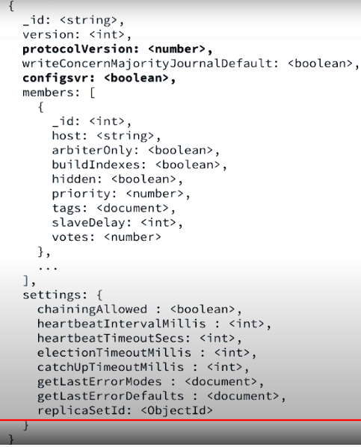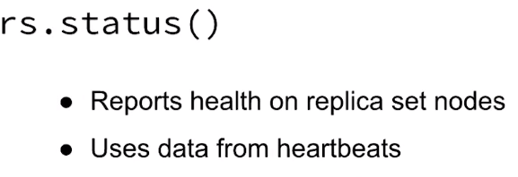

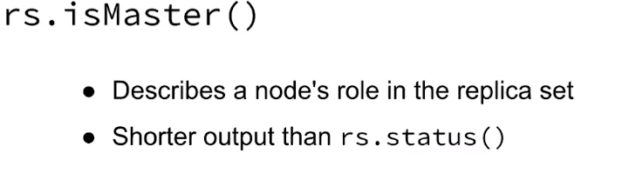

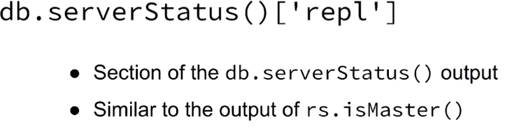

db.serverStatus()[‘rep1’] **This command also show number of rollbacks has been done at this node “rbid:1”**

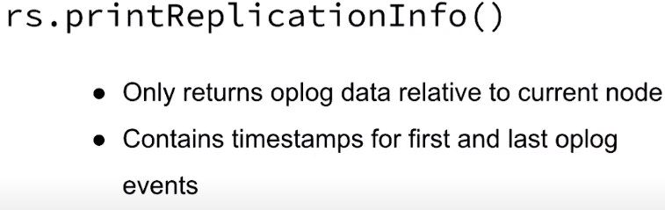

**Local DB –**

**>Show dbs**

Will show two db’s **admin, local.**

**> use local**

**> show collections**

**startup_log**

**Now connect to replica set and check local dB’s collections.**

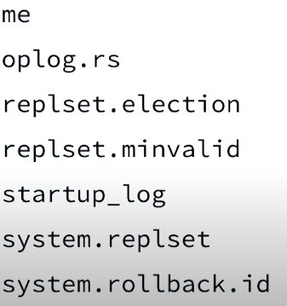

Verifying that this collection is capped (it will grow to a pre-configured size before it starts to overwrite the oldest entries with newer ones):

**>stats.capped**

**>stats.maxSize**

**Oplog.rs** is the central point of replica mechanism **and this is capped collection.**

**It will take 5% of disk space**

**>var stats = db.oplog.rs.status(1024*1024)**

**>stats.maxSize**

**1819**

**>rs.printReplicationInfo()**

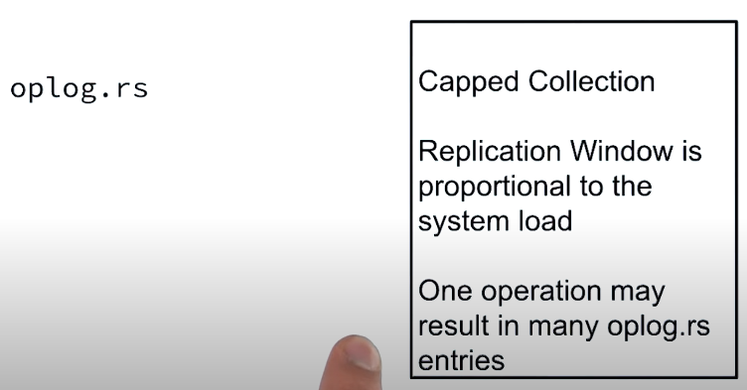

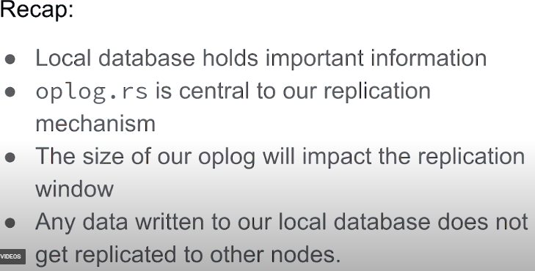

**Reconfiguring Replicase without making restart – (Still Running)**

node4.conf:

storage:

dbPath: /var/mongodb/db/node4

net:

bindIp: 192.168.103.100,localhost

port: 27014

systemLog:

destination: file

path: /var/mongodb/db/node4/mongod.log

logAppend: true

processManagement:

fork: true

replication:

replSetName: m103-example

arbiter.conf:

storage:

dbPath: /var/mongodb/db/arbiter

net:

bindIp: 192.168.103.100,localhost

port: 28000

systemLog:

destination: file

path: /var/mongodb/db/arbiter/mongod.log

logAppend: true

processManagement:

fork: true

replication:

replSetName: m103-example

**Starting up mongod processes for our fourth node and arbiter**:

mongod -f node4.conf

mongod -f arbiter.conf

**From the Mongo shell of the replica set, adding the new secondary and the new arbiter**:

rs.add("m103:27014")

rs.addArb("m103:28000")

**Checking replica set makeup after adding two new nodes**:

rs.isMaster()

**Removing the arbiter from our replica set:**

rs.remove("m103:28000")

**Assigning the current configuration to a shell variable we can edit, in order to reconfigure the replica set:**

cfg = rs.conf()

**Editing our new variable cfg to change topology - specifically, by modifying cfg.members:**

cfg.members[3].votes = 0

cfg.members[3].hidden = true

cfg.members[3].priority = 0

**Updating our replica set to use the new configuration cfg**:

rs.reconfig(cfg)

**Read and Writes on Replica Set**

**Connecting to the replica set:**

mongo --host "m103-example/m103:27011" -u "m103-admin" -p

"m103-pass" --authenticationDatabase "admin"

**Checking replica set topology**:

rs.isMaster()

**Inserting one document into a new collection**:

use newDB

db.new_collection.insert( { "student": "Matt Javaly", "grade": "A+" } )

**Connecting directly to a secondary node (this node may not be a secondary in your replica set!):**

mongo --host "m103:27012" -u "m103-admin" -p "m103-pass"

--authenticationDatabase "admin"

**Attempting to execute a read command on a secondary node (this should fail):**

show dbs

**Enabling read commands on a secondary node:**

rs.slaveOk()

**Reading from a secondary node:**

use newDB

db.new_collection.find()

**Attempting to write data directly to a secondary node (this should fail, because we cannot write data directly to a secondary):**

db.new_collection.insert( { "student": "Norberto Leite", "grade": "B+" } )

**Shutting down the server (on both secondary nodes)**

use admin

db.shutdownServer()

**Connecting directly to the last healthy node in our set:**

mongo --host "m103:27011" -u "m103-admin" -p "m103-pass"

--authenticationDatabase "admin"

**Verifying that the last node stepped down to become a secondary when a majority of nodes in the set were not available:**

rs.isMaster()

**Failover and Elections**

**Storing replica set configuration as a variable cfg:**

cfg = rs.conf()

**Setting the priority of a node to 0, so it cannot become primary (making the node "passive"):**

cfg.members[2].priority = 0

**Updating our replica set to use the new configuration cfg:**

rs.reconfig(cfg)

**Checking the new topology of our set:**

rs.isMaster()

**Forcing an election in this replica set (although in this case, we rigged the election so only one node could become primary):**

rs.stepDown()

**Checking the topology of our set after the election:**

rs.isMaster()

**Write Concerns: Part 1**

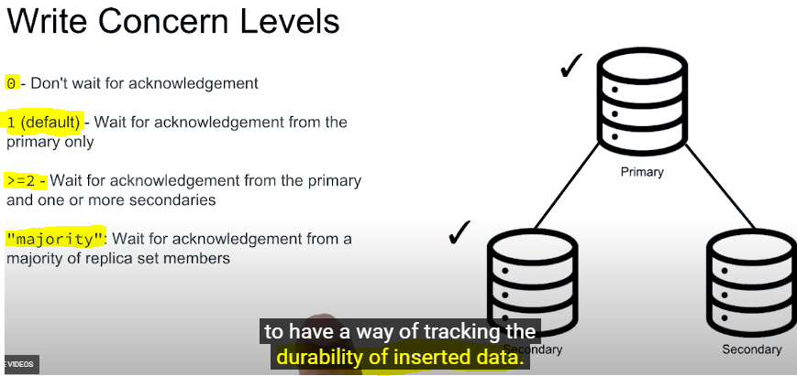

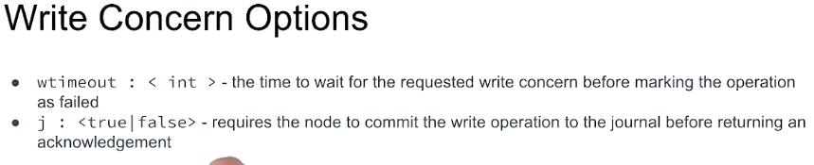

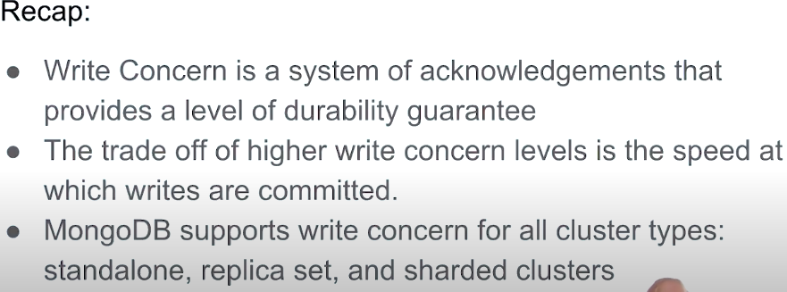

**Read Concerns**

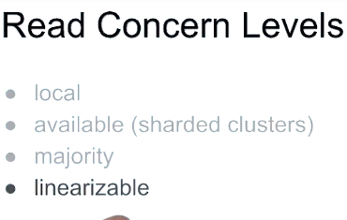

Linearizable – has special behavior like read concern majority it also only returns data that has been majority committed Linearizable goes beyond that and provides read your own write functionality.

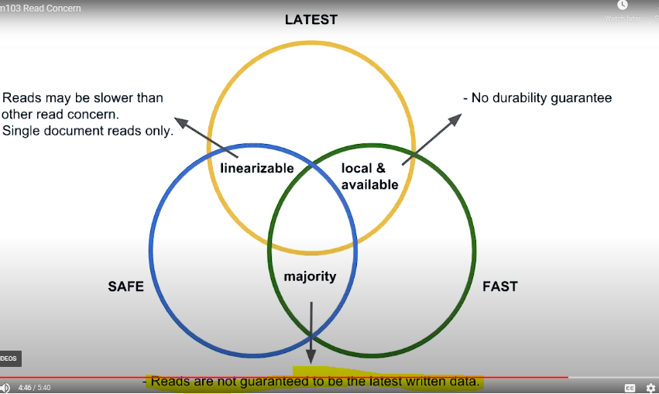

**Read Prefrence : A driver side setting**

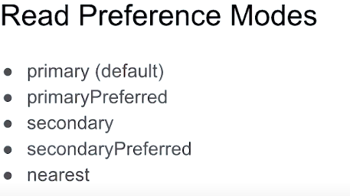

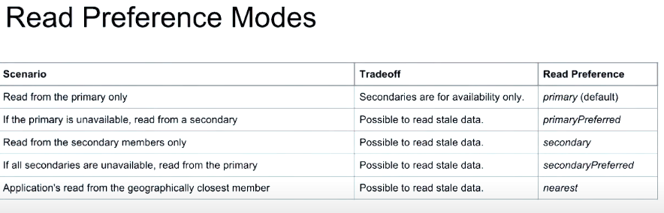

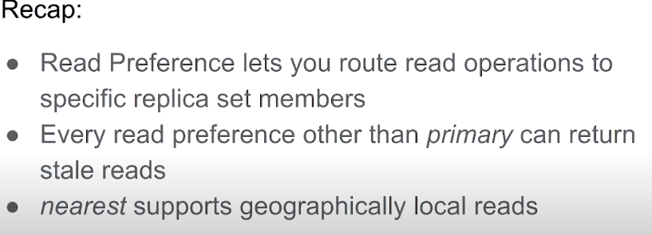

**Sharding Architecture : -**

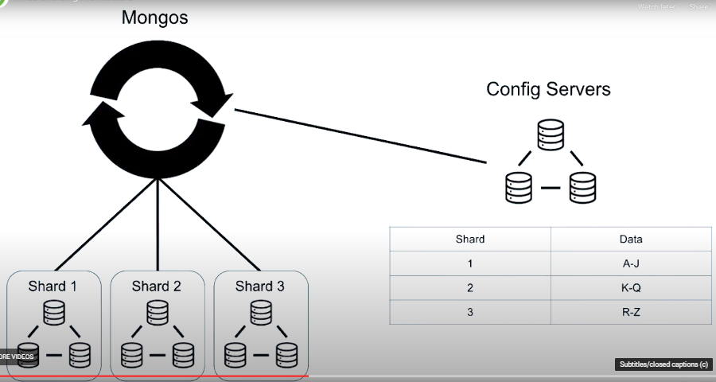

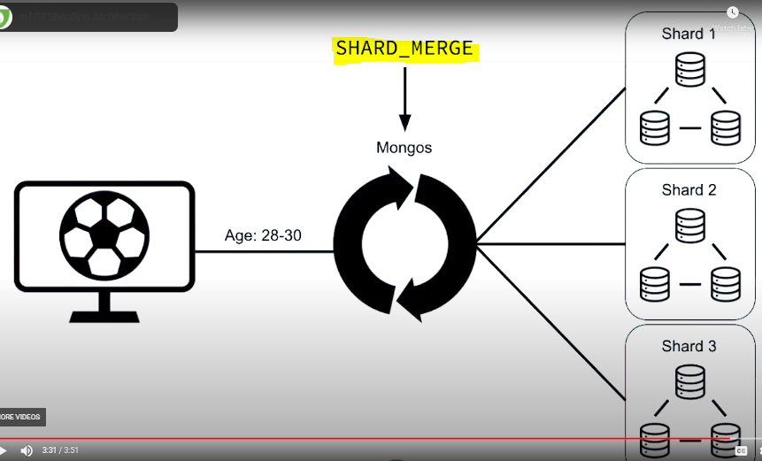

**Setting Up a Sharded Cluster:**

Setting Up a Sharded Cluster

**Configuration file for first config server csrs_1.conf:**

sharding:

clusterRole: configsvr

replication:

replSetName: m103-csrs

security:

keyFile: /var/mongodb/pki/m103-keyfile

net:

bindIp: localhost,192.168.103.100

port: 26001

systemLog:

destination: file

path: /var/mongodb/db/csrs1.log

logAppend: true

processManagement:

fork: true

storage:

dbPath: /var/mongodb/db/csrs1

csrs_2.conf:

sharding:

clusterRole: configsvr

replication:

replSetName: m103-csrs

security:

keyFile: /var/mongodb/pki/m103-keyfile

net:

bindIp: localhost,192.168.103.100

port: 26002

systemLog:

destination: file

path: /var/mongodb/db/csrs2.log

logAppend: true

processManagement:

fork: true

storage:

dbPath: /var/mongodb/db/csrs2

csrs_3.conf:

sharding:

clusterRole: configsvr

replication:

replSetName: m103-csrs

security:

keyFile: /var/mongodb/pki/m103-keyfile

net:

bindIp: localhost,192.168.103.100

port: 26003

systemLog:

destination: file

path: /var/mongodb/db/csrs3.log

logAppend: true

processManagement:

fork: true

storage:

dbPath: /var/mongodb/db/csrs3

**Starting the three config servers:**

mongod -f csrs_1.conf

mongod -f csrs_2.conf

mongod -f csrs_3.conf

**Connect to one of the config servers**:

mongo --port 26001

**Initiating the CSRS**:

rs.initiate()

**Creating super user on CSRS:**

use admin

db.createUser({

user: "m103-admin",

pwd: "m103-pass",

roles: [

{role: "root", db: "admin"}

]

})

**Authenticating as the super user:**

db.auth("m103-admin", "m103-pass")

**Add the second and third node to the CSRS:**

rs.add("192.168.103.100:26002")

rs.add("192.168.103.100:26003")

**Mongos config (mongos.conf):**

sharding:

configDB: m103-csrs/192.168.103.100:26001,192.168.103.100:26002,192.168.103.100:26003

security:

keyFile: /var/mongodb/pki/m103-keyfile

net:

bindIp: localhost,192.168.103.100

port: 26000

systemLog:

destination: file

path: /var/mongodb/db/mongos.log

logAppend: true

processManagement:

fork: true

**Connect to mongos:**

vagrant@m103:~$ mongo --port 26000 --username m103-admin --password m103-pass --authenticationDatabase admin

**Check sharding status:**

MongoDB Enterprise mongos> sh.status()

**Updated configuration for node1.conf:**

sharding:

clusterRole: shardsvr

storage:

dbPath: /var/mongodb/db/node1

wiredTiger:

engineConfig:

cacheSizeGB: .1

net:

bindIp: 192.168.103.100,localhost

port: 27011

security:

keyFile: /var/mongodb/pki/m103-keyfile

systemLog:

destination: file

path: /var/mongodb/db/node1/mongod.log

logAppend: true

processManagement:

fork: true

replication:

replSetName: m103-repl

**Updated configuration for node2.conf:**

sharding:

clusterRole: shardsvr

storage:

dbPath: /var/mongodb/db/node2

wiredTiger:

engineConfig:

cacheSizeGB: .1

net:

bindIp: 192.168.103.100,localhost

port: 27012

security:

keyFile: /var/mongodb/pki/m103-keyfile

systemLog:

destination: file

path: /var/mongodb/db/node2/mongod.log

logAppend: true

processManagement:

fork: true

replication:

replSetName: m103-repl

**Updated configuration for node3.conf:**

sharding:

clusterRole: shardsvr

storage:

dbPath: /var/mongodb/db/node3

wiredTiger:

engineConfig:

cacheSizeGB: .1

net:

bindIp: 192.168.103.100,localhost

port: 27013

security:

keyFile: /var/mongodb/pki/m103-keyfile

systemLog:

destination: file

path: /var/mongodb/db/node3/mongod.log

logAppend: true

processManagement:

fork: true

replication:

replSetName: m103-repl

Connecting directly to secondary node (note that if an election has taken place in your replica set, the specified node may have become primary):

mongo --port 27012 -u "m103-admin" -p "m103-pass" --authenticationDatabase "admin"

**Shutting down node:**

use admin

db.shutdownServer()

**Restarting node with new configuration**:

mongod -f node2.conf

**Stepping down current primary**:

rs.stepDown()

**Adding new shard to cluster from mongos**:

sh.addShard("m103-repl/192.168.103.100:27012")

**Config DB –**

**>Sh.status()** will show sharded cluster info

**>use config**

**Query config.databases:**

>db.databases.find().pretty()

**Query config.collections:**

>db.collections.find().pretty()

**Query config.shards:**

>db.shards.find().pretty()

**Query config.chunks**:

>db.chunks.find().pretty()

**Query config.mongos**:

>db.mongos.find().pretty()

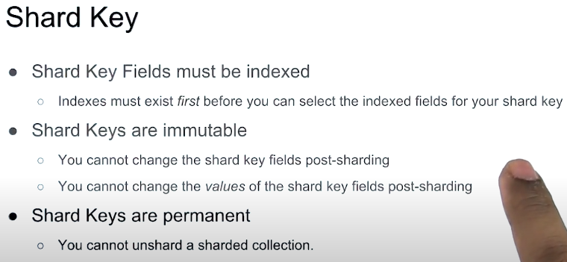



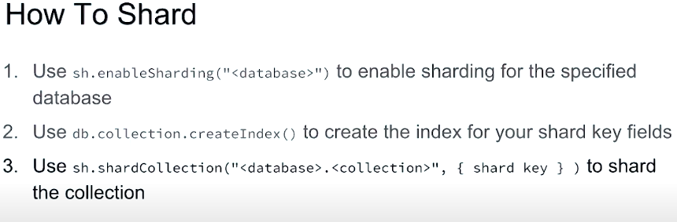

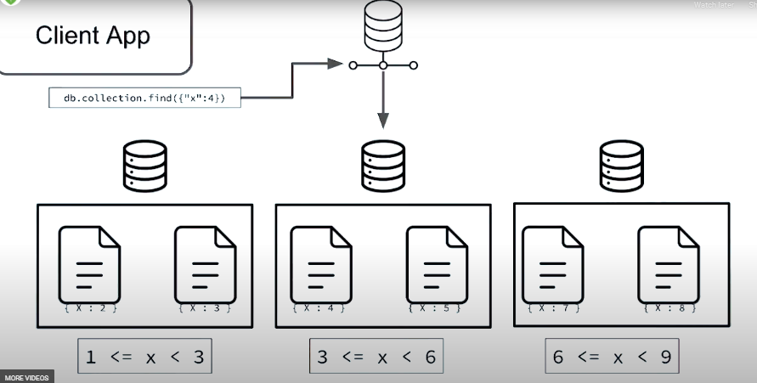

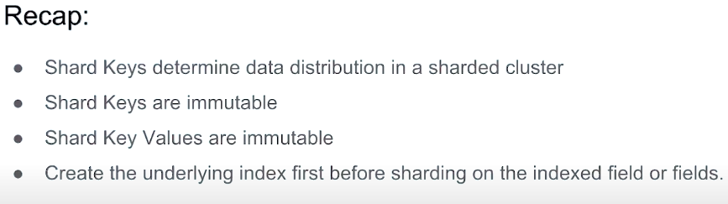

**CREATING A SHARD KEY**

use m103

show collections

Enable sharding on the m103 database:

sh.enableSharding("m103")

Find one document from the products collection, to help us choose a shard key:

db.products.findOne()

Create an index on sku:

db.products.createIndex( { "sku" : 1 } )

Shard the products collection on sku:

sh.shardCollection("m103.products", {"sku" : 1 } )

Checking the status of the sharded cluster:

sh.status()



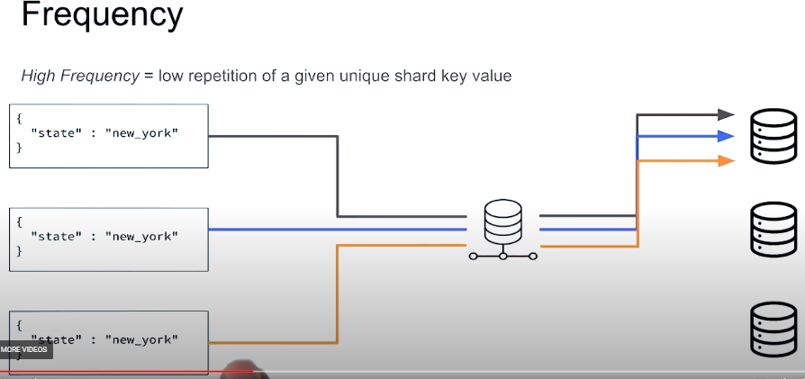

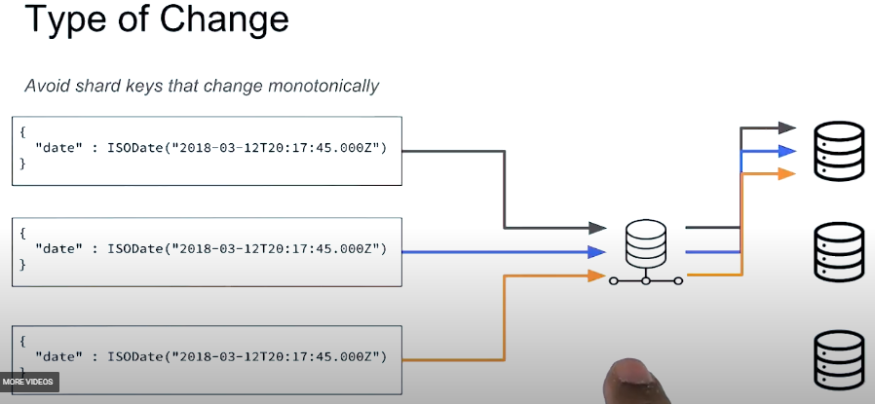

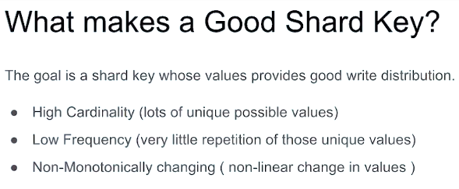

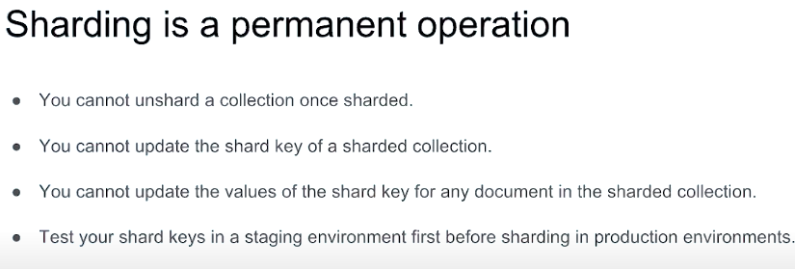

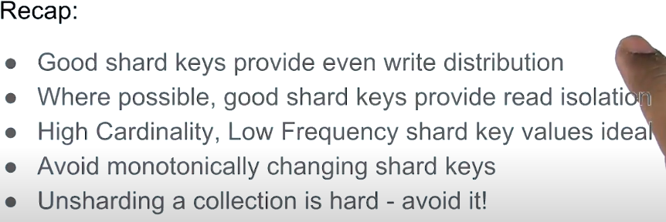

**Hashed Shard Key –** Underlying index is hashed (index)

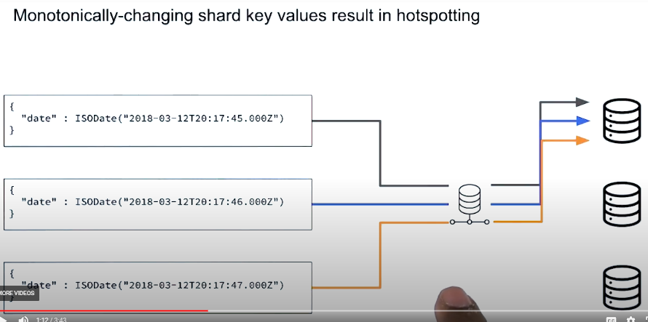

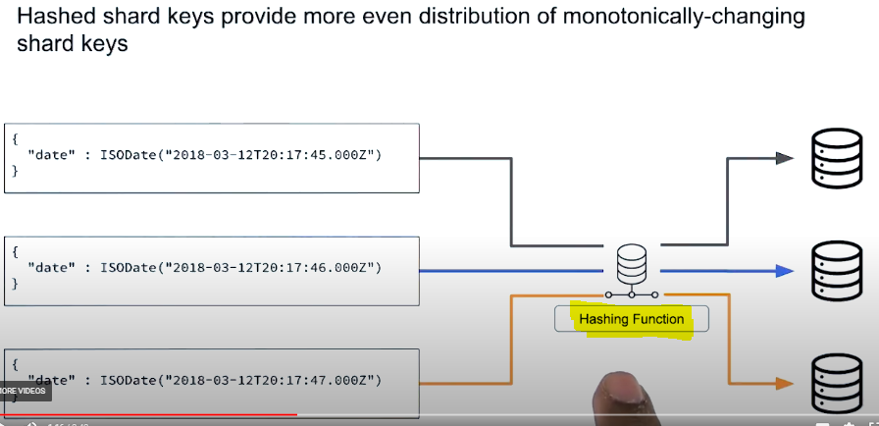

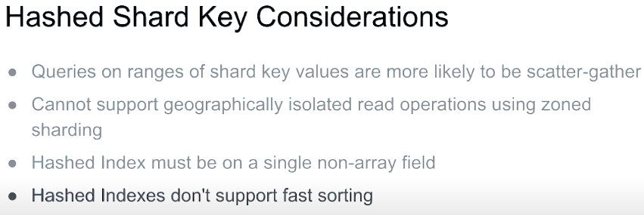

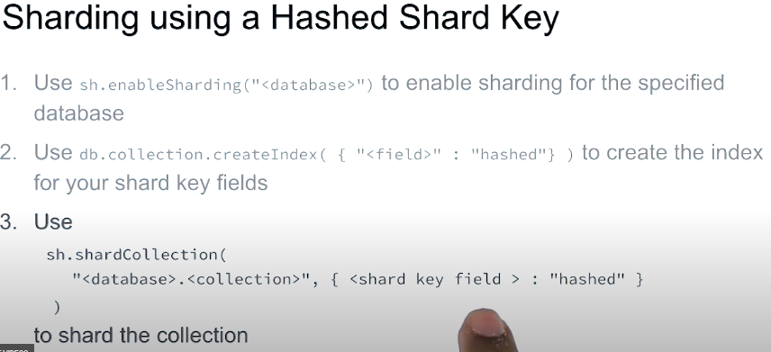

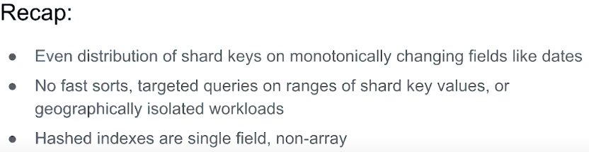

**Chunks – default chunk size 64MB**

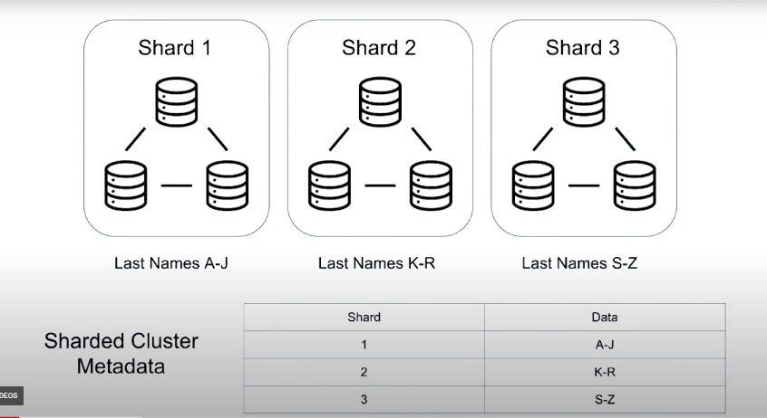

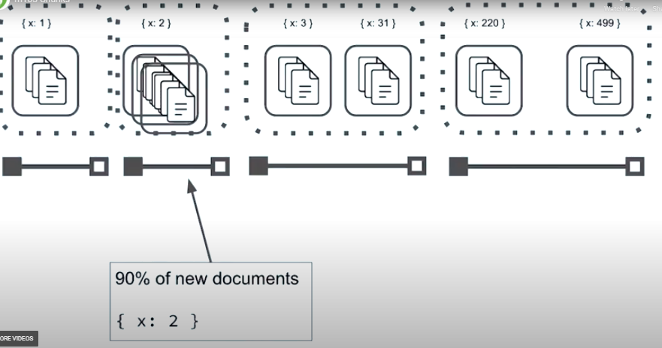

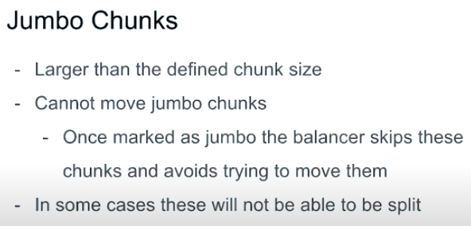

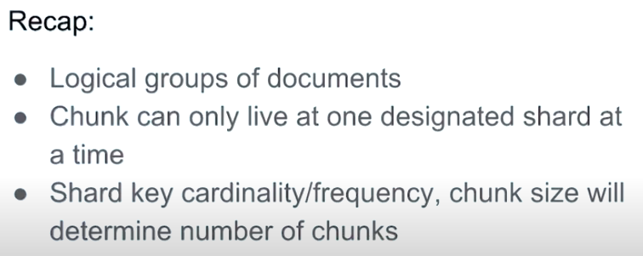

>use config

>show collections

**Find one document from the chunks collection:**

>db.chunks.findOne()

**Change the chunk size:**

>use config

>db.settings.save({_id: "chunksize", value: 2})

**Check the status of the sharded cluster:**

>sh.status()

>mongoimport /dataset/products.part2.json --port 26000 -u "m103-admin" -p "m103-pass" --authenticationDatabase "admin" --db m103 --collection products

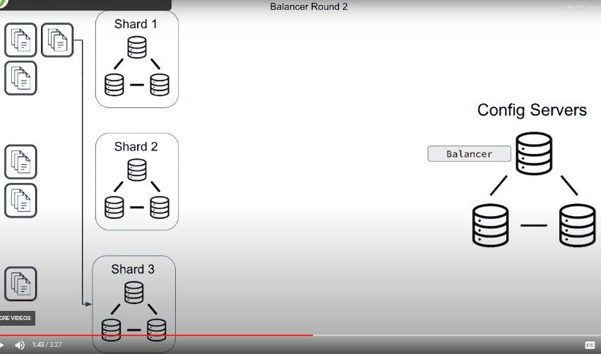**Balancing**

**Start the balancer:**

sh.startBalancer(timeout, interval)

**Stop the balancer**:

sh.stopBalancer(timeout, interval)

**Enable/disable the balancer:**

sh.setBalancerState(boolean)

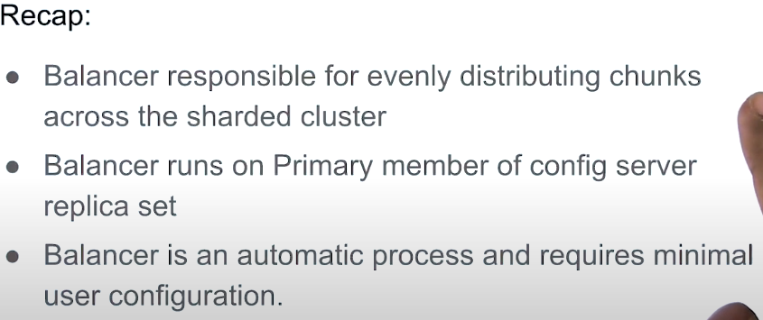

**Queries in a Sharded Cluster** :

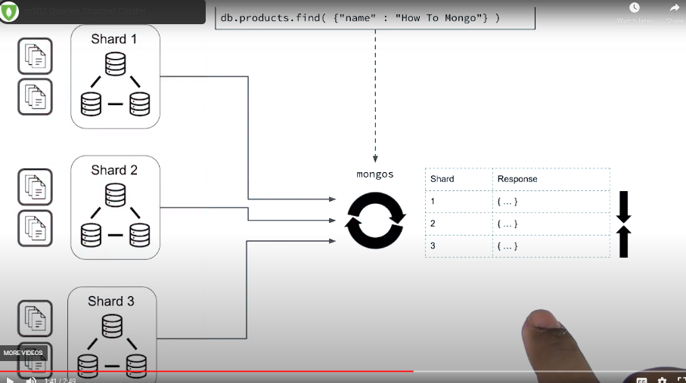

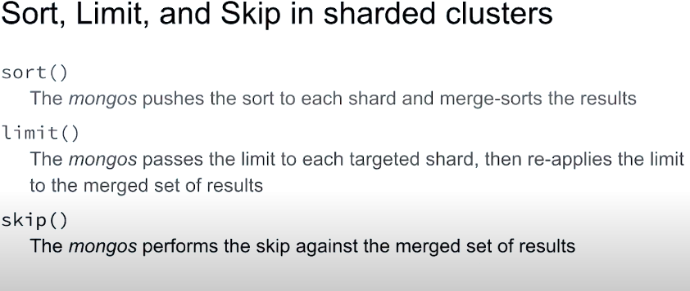

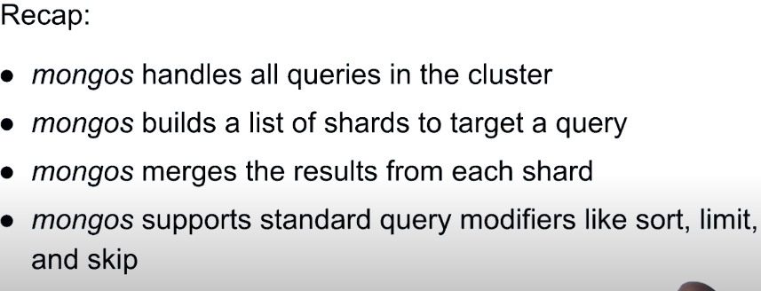

**Targeted Queries vs Scatter Gather: Part 1**

**Targeted:**

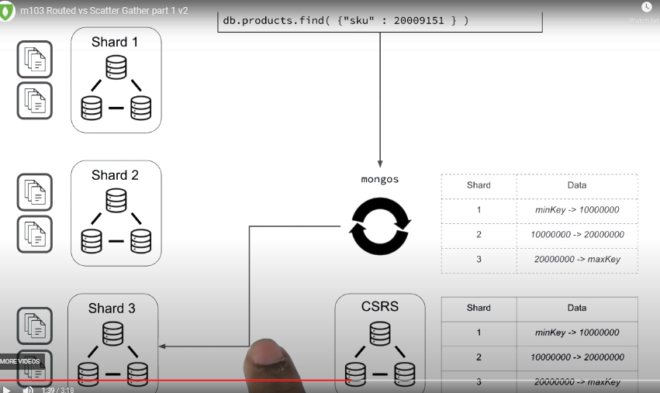

**Scattered :**

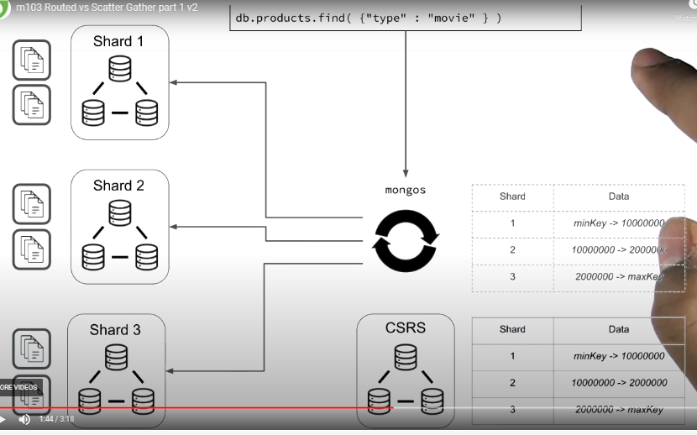

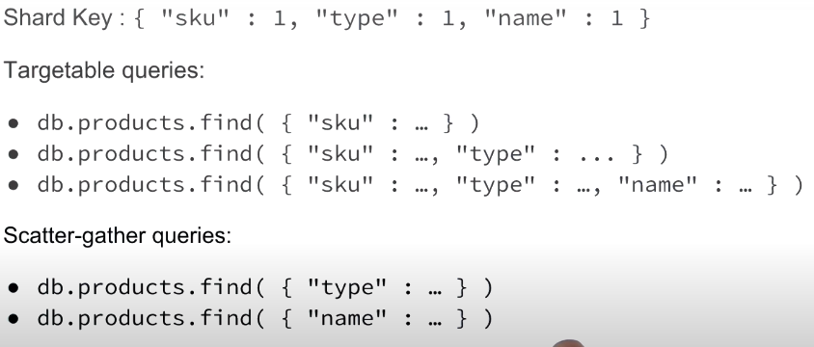

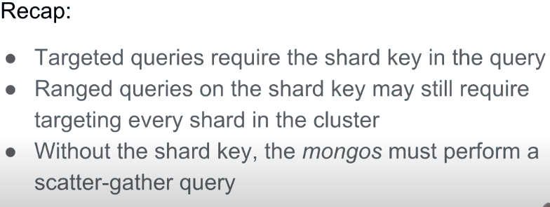

>use m103

>show collections

**Targeted query with explain() output:**

>db.products.find({"sku" : 1000000749 }).explain()

**Scatter gather query with explain() output:**

>db.products.find( {

"name" : "Gods And Heroes: Rome Rising - Windows [Digital Download]" }

).explain()